**Similar Triangles by Angle-Angle**

1. Complete the similarity statement for each pair of similar triangles.

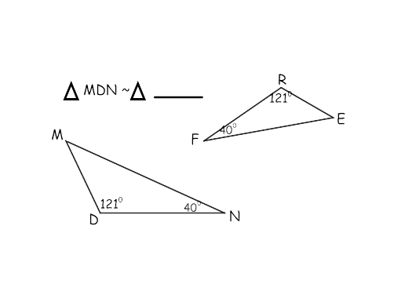

a.

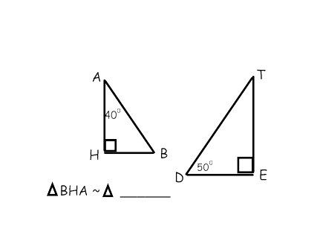

b.

2. Solve for x and or y for each pair of similar triangles.

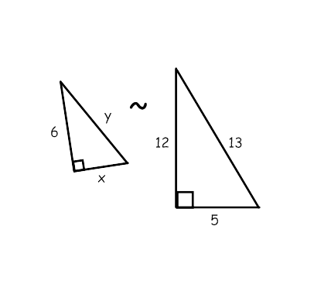a.

x = _______

y = _______

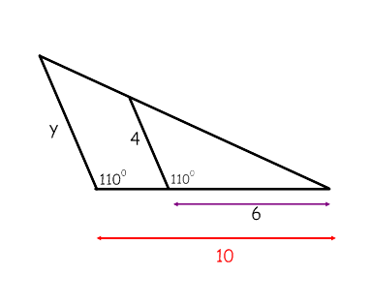

b. y = _______

3. Find the value of x, then find the scale factor.

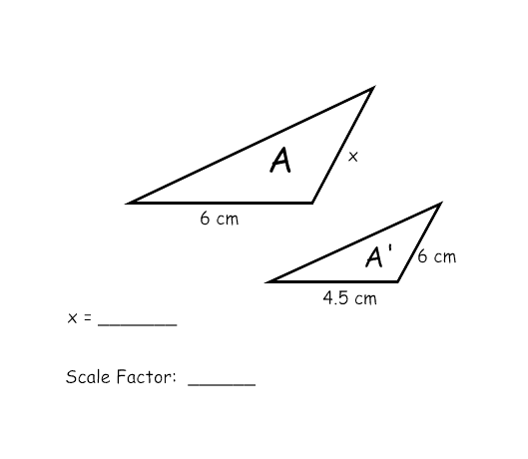

a.

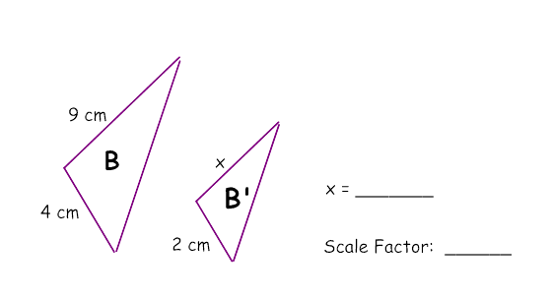

b.