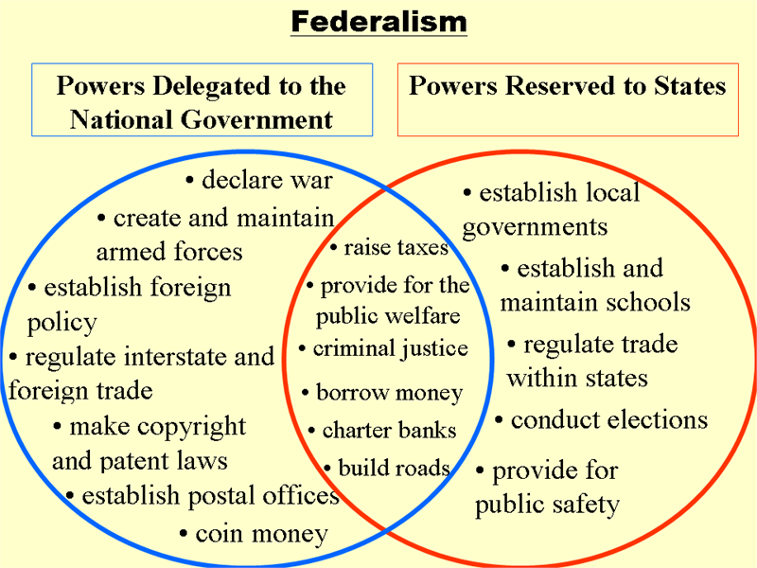

**Federalist vs. Antifederalists**

* Federalists Supported the Ratification of the Constitution
* Antifederalists opposed a strong central government and against the Constitution.

|  |  |
| --- | --- |
| Federalists  -Favored Constitution with a system of checks and balances | Anti Feds  The Gov’t would serve the interests of the privileged |