**Weather and Climate**

**Factors that affect Weather:**

1. ***Latitude***: the closer you are to the equator, __________________________________________________.
2. ***Closeness to a large body of water***:

* Closer to water = Cooler summers and warmer winters
* Far from water= _______________________________________
* Cities located at the same elevation and latitude can have different yearly average temperatures because of this!

1. ***Ocean Currents***: cold current cools the climate. Warm current __________________________.
2. 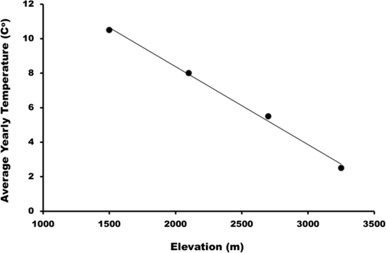***Elevation:*** The higher you are, ______________________

**Pressure Systems**

Air pressure is measured using an instrument called a ______________________

Wind **ALWAYS** wants to blow from _________ pressure to __________ pressure

**[](http://www.google.com/imgres?imgurl=http://thumbs.dreamstime.com/z/sun-cartoon-character-thumb-up-illustration-31345101.jpg&imgrefurl=http://www.dreamstime.com/royalty-free-stock-image-smiley-sun-clip-art-image5508716&h=1306&w=1300&tbnid=4yQCB3kXCweSMM:&zoom=1&q=sun&docid=BZvO0ITw1debbM&ei=Ez1vVJW2D_eSsQSK2IDYCA&tbm=isch&ved=0CF0QMyg0MDQ&iact=rc&uact=3&dur=697&page=3&start=51&ndsp=30)High Pressure** =__________ and ___________

___________ and _____________

[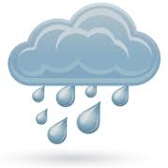](http://www.google.com/imgres?imgurl=http://www.bt-store.com/content/images/weather/prep_8.png&imgrefurl=http://www.bt-store.com/cheap-flights-to/bucharest/MIA&h=224&w=224&tbnid=imnIbHj_LQEW-M:&zoom=1&q=cloudy%20and%20rainy&docid=M_vng4opAPVfpM&ei=qz5vVK-SHIyNsQTjiIDgCg&tbm=isch&ved=0CCoQMygOMA4&iact=rc&uact=3&dur=1235&page=1&start=0&ndsp=20)

* When air pressure increases – skies are clearing

**Low Pressure** = ____________ and __________

__________ and ___________

* When air pressure declines –____________________________

**Air Masses**

* **mP – maritime Polar –___________and ______________**
* **mT – maritime Tropical –______________and_______________**
* **cP – continental Polar –____________and _______________**
* **cT – continental Tropical –___________and _______________**
* **cA – continental Arctic – ____________ and __________________**

**How do storms occur?**

**Shade the areas that would be experiencing precipitation.**

[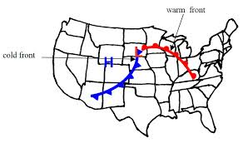](http://www.google.com/imgres?imgurl=http://lablearner.com/v2gr8/wp-content/uploads/2014/02/Fronts.jpg&imgrefurl=http://lablearner.com/v2gr8/?page_id%3D5666&h=480&w=812&tbnid=ql5UdqQR_fmmwM:&zoom=1&q=diagram%20with%20cold%20and%20warm%20fronts%20meeting&docid=TiULllPtdzVgaM&ei=qW5vVL2NKfHfsATM_4K4AQ&tbm=isch&ved=0CGAQMyhYMFg4yAE&iact=rc&uact=3&dur=3100&page=12&start=269&ndsp=26)

**[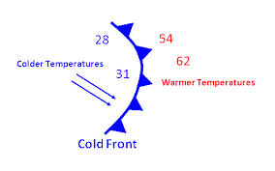](http://www.google.com/imgres?imgurl=http://chiliweb.southalabama.edu/education/images/WeatherFronts/fronti5t.png&imgrefurl=http://chiliweb.southalabama.edu/education/index.php?page%3Dweatherfronts&h=330&w=528&tbnid=u2TBpiDFLLN3tM:&zoom=1&q=cold%20front&docid=4vz7PqQjqVsVuM&ei=6W9vVPvlHam1sATcnoCgCg&tbm=isch&ved=0CCIQMygGMAY&iact=rc&uact=3&dur=17265&page=1&start=0&ndsp=19)[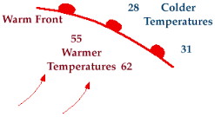](http://www.google.com/imgres?imgurl=http://ww2010.atmos.uiuc.edu/guides/mtr/af/frnts/wfrnt/gifs/def1.gif&imgrefurl=http://ww2010.atmos.uiuc.edu/(Gh)/guides/mtr/af/frnts/wfrnt/def.rxml&h=169&w=309&tbnid=sZs2XEruTQmBIM:&zoom=1&q=warm%20front&docid=Vir98b9agmqX6M&ei=P3BvVM37L_T8sAS_1YBg&tbm=isch&ved=0CBwQMygAMAA&iact=rc&uact=3&dur=1323&page=1&start=0&ndsp=16)**

**Storms occur where the two fronts *meet, NOT ___________________________________________________***