

Harbor Sound Enterprises

*“Raising the Bars”*

**82 Turkey Lane Cold Spring Harbor, NY, 11743 631-367-6993**   **Harborsoundny.weebly.com** **Twitter**: **@HarborSound_NY** **Harborsoundenterprises.ny@veinternational.org**

Table of Contents

1. Executive Summary 2
2. About the Business 2

Description 2

Mission Statement 3

Management Functions 3

Planning: 3

Organizing: 4

Directing 5

Controlling 5

SWOT Analysis 6

1. External Environment 7

Current Economic Conditions 7

Real Industry Analysis: 8

Virtual Industry Analysis: 10

1. Marketing Plan 10

Target Market and Market Segments (Our Industry): 10

Marketing Mix 10

Product: 11

Pricing 12

Placement 12

Promotion: 12

Discussion of Business Risks 12

1. Financial Planning 14

Break Even Analysis 14

Income Statement 18

Balance Sheet 19

Cash Budget 20

Financial Summary 21

VI. **APPENDIX** 22

# EXECUTIVE SUMMARY

Harbor Sound Enterprises a new revolutionary speaker company. Whether you are in the market to rent or purchase a speaker, our very qualified associates will help you find the perfect fit for your specific need. Excellent sound and performance is our main focus so when you purchase a Harbor Sound speaker, you are not only investing in a quality speaker but in a good time.

All our employees here at Harbor Sound Enterprises are music enthusiasts. We pride ourselves in modern efficiency of our products. Not only can connect to our speakers through USB and Bluetooth but also through our built in program that allows you to create a custom music profile.

Harbor Sound Enterprises is committed to being the life of the party. We encourage you to try out our products and witness first-hand how Harbor Sound Enterprises raises the bar.

# ABOUT THE BUSINESS

## Description

In September 2016, thirteen motivated intellectuals decided to open *Harbor Sound Enterprises*. Here at *Harbor Sound Enterprises,* we offer speakers for any event in your house, on your boat, or even on the go! We offer an array of different cases, headphones, and accessories that are convenient for any occasion! Each and every one of our employees has put their uttermost effort and time into ensuring that the quality of our products is of the highest grade, all at an affordable price.

*Harbor Sound Enter*prises is a New York B-Corporation originated on September 6th, 2016. *Harbor Sound Enterprises* headquarters is located in Cold Spring Harbor, New York.

## Mission Statement

# Our mission is to provide and develop innovative high quality products, which we offer at the best value to our customers. We provide our customers with the next generation experience, through our deep knowledge of the changing global and consumer technology.

* To design, engineer, and manufacture superior quality professional audio products.
* To be the best-in-class global provider and marketer of speakers through innovation, modern product development, continuous improvement, and brand building.
* To conduct our company based on honesty and integrity.
* To exceed the needs and expectations of our consumers for products and services through the proactive efforts of our employees.

## Management Functions

### Planning:

### Guided by our four consultants, the Chief Executive Officer, the Chief Operating Officer, and Chief Financial Officer will be responsible for setting the company’s goals.

|  |  |
| --- | --- |
| **Goals of the Business** | **Strategies to Achieve Goals** |
| * Product Development | * Design and conduct surveys to better understand our customers wants |
| * Marketing and Promotion | * Design creative marketing material to attract customers. Develop clever marketing and promotional opportunities. |
| * Advertise our products | * Create mini commercials to be broadcast on morning announcements * Advertise on main VE website * Offer deals to other companies to do business with our company and their company |
| * Attain sale targets | * Offer incentives to employees to grow sales throughout country. |
| * Fiscal Responsibility | * Conduct feasibility studies to determine where to spend marketing money wisely; monitor and control costs. |

### Organizing:

|  |
| --- |
| ***Organizational Chart*** |
|  |

Given the small size of Harbor Sound Enterprises, all employees will be required to pitch in whenever and where ever help is needed. There are four veteran company consultants, each responsible for one functional area. The primary role of the four consultants is to mentor the employees and emphasize the importance of multi-tasking to ensure goals are met.

### Directing

In our company, the consultants provide the support and guidance to the rest of the staff. The CEO is responsible for holding periodic meetings for the company to ensure that all are kept apprised of the direction and short term goals of the company.

***Controlling***

Each consultant will spear head a particular competitive event. The assigned consultant will put task markers in place to ensure that deadlines are met.

## SWOT Analysis

|  |  |  |
| --- | --- | --- |
| **Internal Origin** | STRENGTHS   * B-Corp * Growing market * Large market * Enthusiastic employees * New concept | WEAKNESSES   * Small Business * No previous experience * Slow start for sales * Lots of competition * Intricate product development |
| **External Origin** | OPPORTUNITIES   * Internet as a marketing tool; website, twitter * Seasonal high demand of the product * Customer loyalty * Increased investment opportunities * Growing Market | THREATS   * Competition * More experienced companies * Rising material prices * Small Business * International Businesses |

# EXTERNAL ENVIRONMENT

## Current Economic Conditions

Assessment of the Environment

The consumer sentiment is a measure of the consumer’s belief as to whether the economy projected to accelerate or decelerate. The global home audio equipment market shown in the graph below, from 2012-2019, shows a steadily increasing trend starting at 15.94 billion USD.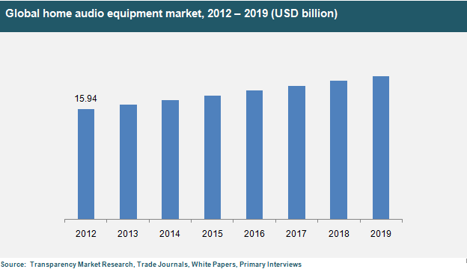

The GDP is the measure of the Gross Domestic Product, which is the growth rate based on the United States economy. The chart below shows the trend line for the GDP decreasing from 2014-2017 from 2.5%to 1.8%. A decreasing GDP rate is unfavorable to launch a new business.

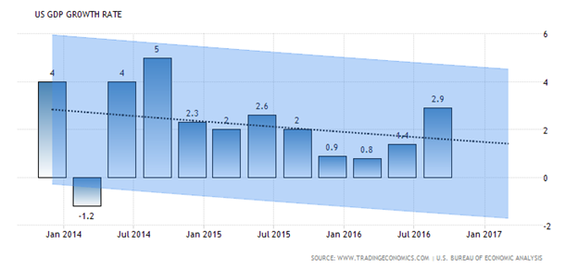 Based on the graph below the U.S. disposable personal income has greatly increased within the past year. Today’s disposable income sits at over $11,800 billion compared to $10,860 billion back in summer of 2008. Since the overall growth trend is up, this means Americans are more eager and willing to spend their money, this is favorable to a new business. Small businesses are benefiting in result, this is shown by the optimism among small businesses, it rose by 1.4 points to a total of 96.6 out of 100.

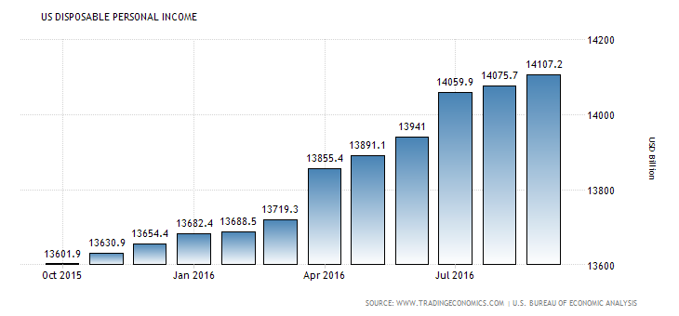

## Real Industry Analysis:

As for the current speaker's market, the possibilities are endless. According to TechNavio's analysts forecast, the Global Bluetooth Speaker market is expected to grow at a CAGR of 38.73 percent during the forecast period 2014-2019. In previous years such as 2015, speaker systems held the largest market size. Furthermore, bluetooth technology is expected to dominate the wireless audio market. According to ABI research, the speaker market is projected to be worth nearly $61 million by 2018. Speaker sales are driven by high ownership rate of smartphones which hit 75% in North America according to Futuresource, and 64% of those people play music through other devices from their phones.

|  |  |
| --- | --- |
| **Key Regions**   * APAC * Europe * US * ROW | **Key Vendors**   * Bose * Harman International Industries * Philips * Sennheiser Electronic * Sony |
| **Other Prominent Vendors** | |
| * Apple * LG * Panasonic * Plantronics * Polk Audio | * Samsung * Shure * Vizio * Voxx |
| **Market Driver**   * Increased Convenience | **Market Challenge**   * Limited Range |

## **Virtual Industry Analysis:**

We have very few competitors in the Virtual Enterprise market. The only other company selling items similar to ours is TRUBLU Technologies. This company is located in Smithtown, NY, and they sell Bluetooth speakers. Harbor Sound plans on saturating the local VE market place with promotional material to gain regional marketshare.

# MARKETING PLAN

## Target Market and Market Segments (Our Industry):

Harbor Sound Enterprises products will be marketed to stores that are able to cover a wide range of items. This includes markets such as superstores, private shops that are interested in new technology, and shops that are focused on the music industry.

Harbor Sound Enterprises is focused on selling our product mainly to 15- 40 year olds. Within this wide range of ages, women, men, families, athletes and music enthusiasts are included. Harbor Sound Enterprises products will be available to almost anyone that would like to buy them. We have competitively priced our products so that many people will be able to purchase our items. Our main consumers are located primarily in densely populated urban areas along the east coast. We are hoping to appeal to consumers who are outgoing, energetic and live an entertaining life.

## Marketing Mix (Product, Pricing, Placement)

Our company is composed of 5 different products. We produce 4 different types of speakers and 1 type of head phone all of which ensure the best sound and the best quality materials. Harbor Sound Enterprises is active on social media such as Twitter (@HarborSound_NY) and we have also created our own online website (harborsoundny.weebly.com) in order to actively communicate with our customers. We will enter into contracts with local vendors to distribute our products locally as part of our non VE sales projection. Themed monthly sales will take place within our school environment to further increase non-VE sales. We will also distribute our product throughout the VE network.

### Products

|  |  |
| --- | --- |
| Headphones $120   * Noise cancelation * Solo HD High-performance * Code: HSEHP | The Party Box $120   * Bluetooth * USB connection * Code: HSEPB |
| The Boat Box $175   * 450 watt * Waterproof enclosure * Code: HSEBB | The Popo Magnet $300     * Optimized for ideal acoustic resonance * JBL Waveguide Technology * Code: HSEPPM |
| Jukebox 2.0 $200     * Aux in audio * 3.5mm aux in jack * Code: HSEJB | |

### Pricing

Harbor Sound Enterprises is competitively priced but also based on the penetration strategy in order to appeal to the majority of consumers.

### Promotion:

### Given the fun party nature of our products we hope to encourage sales through multiple promotional efforts. Some of our strategies will include:

### Commercial Advertisements: We could produce monthly mini commercials to be run during our morning announcements to promote in house non-VE sales.

### Seasonal Sale Opportunities: Due to the nature of our products which would make perfect gift ideas, we could offer additional incentives around major holidays.

### Free Months of Music streaming: Motivate our customers to purchase our products by a specific date by offering short term free music streaming such as Spotify, Pandora or XM radio.

* + VE Partner promotional Events: Through partnerships with other VE companies such as local tailgate company, we could co-market our products to get wider distribution.

## Discussion of Business Risks

There are many business risks that need to be accounted for in the speaker

industry. There could be an issue in the raw materials used to produce our speakers resulting in a recall. A recall could cause major profit losses and/or a loss of business. In case of a shift in certain product demands, we must actively monitor the number of sales of each specific product regularly. If the rules of operation for our factories change then we must adapt so we don’t have any detrimental problems. The potential of facing a major lawsuit is possible, and we have to be ready for the consequences of one. There are reputational risks, that could include negative publicity. Additionally, there are compliance risks such as laws regarding the speaker industry and making sure we obey them.

# FINANCIAL PLANNING

## Break Even Analysis

## Income Statement

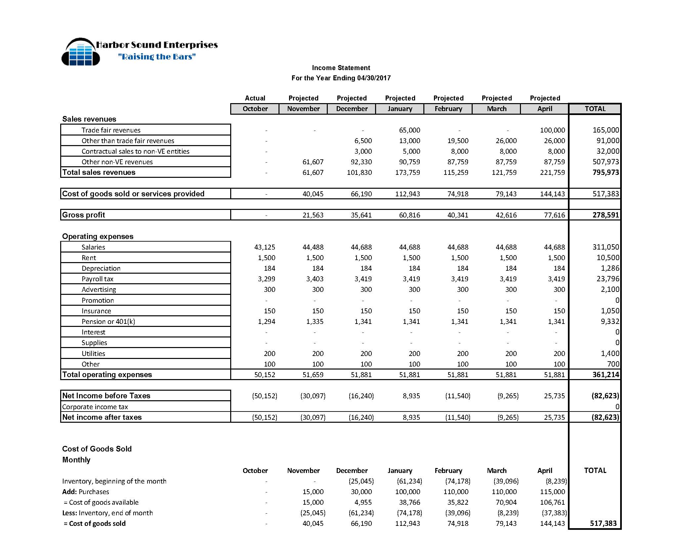

## Balance Sheet

**Financial Summary**

***Income Statement***

***Balance Sheet***

# Appendix

## Bank Statement

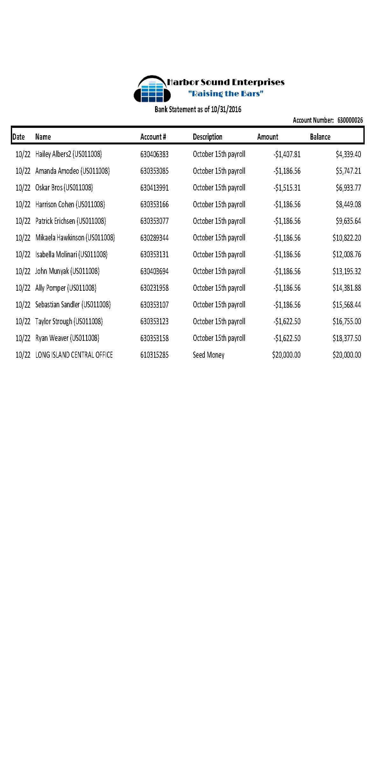

Loan Amortization 