**Army’s first female infantry officer is Capt. Kristen Griest, Ranger School graduate**

The inside track on Washington politics.

**April 27**

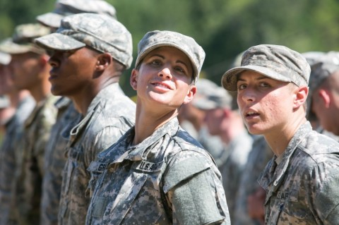  
Capt. Kristen Griest, left, and 1st Lt. Shaye Haver during the graduation ceremony for the U.S. Army’s Ranger School on Aug. 21, 2015, at Fort Benning, Ga. (Jessica McGowan/Getty Images)

When Capt. Kristen M. Griest made history last summer by becoming one of the first two women to graduate the Army’s legendarily difficult Ranger School, she made her intentions clear: She was considering joining a Special Operations unit. Now, she has accomplished another first with some similar demands: becoming the U.S. military’s first female infantry officer.

____________________________________

____________________________________

____________________________________

Griest, 27, requested a transfer to become an infantry officer, and it was accepted Monday, said Lt. Col. Jerry Pionk, an Army spokesman. On Thursday, she will graduate from the Maneuver Captains Career Course at Fort Benning, Ga., which teaches students how to do tactical planning for infantry companies and battalions and lead as a company commander.

“Like any other officer wishing to branch-transfer, Capt. Griest applied for an exception to Army policy to transfer from military police to infantry,” said Bob Purtiman, a spokesman for  the Maneuver Center of Excellence at Fort Benning. “Her transfer was approved by the Department of the Army, and she’s now an infantry officer.”

____________________________________

____________________________________

____________________________________

*[*[*How the first female graduates of Ranger School made it through the legendary school*](https://www.washingtonpost.com/world/national-security/how-did-these-two-women-become-the-first-to-complete-army-rangers-school/2015/08/19/a745c962-46af-11e5-8ab4-c73967a143d3_story.html)*]*

The news was first reported Wednesday [by the independent Army Times](http://www.armytimes.com/story/military/careers/army/officer/2016/04/27/meet-armys-first-female-infantry-officer/83591066/) and [the Columbus Ledger-Enquirer newspaper near Fort Benning](http://www.ledger-enquirer.com/news/local/military/article74173042.html). Purtiman told The Washington Post that a graduation ceremony for Griest and fellow captains career course students will be held Thursday, but it will not be open to media.

Griest, of Orange, Conn., entered the Army as a military police officer after earning her commission in 2011 at the U.S. Military Academy at West Point, N.Y. A former high school cross-country runner, she was one of 19 women who attempted Ranger School last year beginning in April as the service opened it to women for the first time while researching how to more fully integrate women in the military.

____________________________________

____________________________________

____________________________________

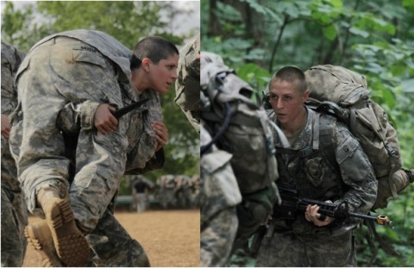  
Kristen Greist, left, and Shaye Haver, right, became the first female soldiers ever to graduate Ranger School in August 2015. (Photos by by Spec. Nikayla Shodeen and Pfc. Ebony Banks/ U.S. Army)

In August, Griest and 1st Lt. Shaye Haver, an Apache helicopter pilot and fellow West Point graduate, became the first women to graduate Ranger School. They were followed in October by Maj. Lisa Jaster, another West Point graduate, a combat engineer who activated from the Army Reserve to attempt the course.

Griest was unavailable for comment Wednesday, but told reporters before her graduation from Ranger School last summer that she was interested to see what new doors would open for women in the military.

____________________________________

____________________________________

____________________________________

“I think that Special Forces is something that I would definitely be interested in if my timeline permits for that,” Griest said. “Currently, I’m trying to pursue civil affairs, which is under the Special Operations umbrella that is currently open to women. But there are several other options out there, and I’m honestly not very decided about it.”

Privately, however, Griest “talked about wanting to be in the infantry since the first time I met her,” Jaster told The Washington Post on Wednesday after Griest’s new accomplishment was reported.

____________________________________

____________________________________

____________________________________

“I am proud of her for following her dreams and setting the example for future male and female soldiers,” Jaster added.

Griest is one in what could be a series of firsts for women in the military this year. Defense Secretary Ashton B. Carter announced in December that that he was removing all bans on women serving in combat units, and he gave the services until this year to determine how they would do so.

Earlier this month, the Army announced that it approved requests from nine female cadets to join the infantry and 13 to join the armor branch, which also was opened to women for the first time this year. After commissioning, the new officers are expected to go through training this summer and could carry out their desired jobs by this fall.

____________________________________

____________________________________

____________________________________

One female officer washed out of the Marine Corps Infantry Officer Course last week, and is expected to attempt it again, defense officials said. Thus far, 30 women have attempted that course and none have passed.

# Army Ranger TrainingUS Army Rangers

Military.com

Like all Ranger candidates you will begin with nine weeks of Boot Camp. Upon completion of Basic Training you will attend Advanced Individual Training to earn your Military Occupational Specialty (MOS). This training varies in length depending on your selected MOS.

**Tip:** Each MOS also has its own specific [ASVAB](http://www.military.com/ASVAB) requirements. Scoring high on the ASVAB is key to being able to choose an MOS that offers the highest bonuses and the best career opportunities in the Army. Visit our [Ace the ASVAB](http://www.military.com/ASVAB) section to learn how to make sure you qualify for the bonuses and career options you deserve.

After graduating AIT your training will continue at Army Airborne School and then on to the Ranger Indoctrination Program (RIP) in Fort Benning, GA.

**Army Airborne School**  
Your next step will be to complete Airborne training. Airborne School is a unique experience requiring special dedication and a desire to be challenged mentally and physically. This three-week course, also known as Basic Airborne Training, teaches you the techniques involved in parachuting from airplanes and landing safely. The final test includes a non-assisted jump.

Airborne school is broken down into 3 weeks. The following explains the training you must complete for each week.

****Ground Week:****You start with an intensive program of instruction to build individual airborne skills. These skills prepare you to make a parachute jump and land safely. You will train on the mock door, the 34-foot tower and the lateral drift apparatus.

****Tower Week:****  
Tower Week completes your individual skill training and builds your team effort skills. To go forward to Jump Week, you must qualify on the Swing Lander Trainer (SLT), master the mass exit procedures from the 34-foot tower, and pass all physical training requirements.

****Jump Week:****During Jump Week, you must successfully complete five jumps at 1,250 feet from a C-130 or C-141 aircraft. If you successfully meet the course requirements you will be granted an additional skill identifier and will be authorized to wear the coveted "Silver Wing" on your uniform.

When you graduate from Airborne School you will be assigned to the 75th Ranger Regiment to attend the Ranger Indoctrination Program (RIP).

****The Ranger Indoctrination Program****  
The Ranger Indoctrination Program (RIP) begins when the Ranger Liaison picks up the Ranger candidates at Airborne School - just after graduation - to immediately begin the program. The program is designed to determine if you are suitable for service in the 75th Ranger Regiment.

The four-week program consists of physical training and continuous preparation for service in the Regiment. It is important that you learn the operational procedures, equipment, and the standards of the Regiment prior to your assignment.

The Ranger Indoctrination Program includes the following training:

* Daily Physical Training
* Ranger History test
* Map Reading
* APF
* Airborne Operation
* Ranger Standards
* Day and night land navigation
* 5-mile run
* Combatives
* Knots
* Combat Water Survival Test
* 6, 8 and 10-mile road marches
* Driver Training (DDC Card)
* Fast Rope Training
* Combat Lifesaver certification

To pass RIP and qualify for the 75th Ranger Regiment you must meet the following criteria:

* Score 60 percent on the Army Physical Fitness Test (APFT) in the 17 to 21 age group
* Complete a 5-mile run in less than 8 minutes per mile
* Successfully complete the Combat Water Survival Test (CWST) - You must be able to complete 15 meters in BDU's, boots and LBE.
* You must complete 2 of 3 road marches, one of which must be a 10-mile road march
* You must score at least 70 percent on all exams

Once you have completed RIP, you will finally be a Ranger and you will receive an assignment to either the 75th Ranger Regiment Headquarters or one of the three Ranger Battalions.

**Ranger School**  
After you have proven yourself at your Ranger Battalion your next step will be to go to Ranger School. This school is a requirement for becoming a Non-Commissioned Officer (NCO) in the Rangers.

Ranger School is one of the toughest training schools a soldier can volunteer for. Army Ranger NCOs are experts in leading soldiers on difficult missions-and to do this they need rigorous training. For over two months, Ranger students train to exhaustion, pushing the limits of their minds and bodies.

There are three distinct phases of Ranger School that require soldiers to make quick decisions in adverse situations-these phases are called "crawl," "walk" and "run."

**Crawl (Darby) Phase**  
The Crawl Phase lasts 20 days. It's designed to assess and develop the necessary physical and mental skills to complete combat missions and the remainder of Ranger School successfully. If you are not in top physical condition when you report to the Ranger School, you will have extreme difficulty keeping up with the fast pace of Ranger training, especially during this first phase.

**Walk (Mountain) Phase**  
The Walk Phase takes place in the mountains and lasts 21 days. During this phase, you will receive instruction on military mountaineering tasks as well as techniques for employing squads and platoons for continuous combat patrol operations in a mountainous environment. You will further develop your ability to command and control a platoon-sized patrol through planning, preparing and executing a variety of combat patrol missions.

**Run (Swamp) Phase**  
The Run Phase of Ranger School continues to develop your combat arms functional skills. You must be capable of operating effectively under conditions of extreme mental and physical stress. This is accomplished through exercises in extended platoon-level patrol operations in a swamp environment. Run Phase training further develops your ability to lead small units on airborne, air assault, small boat, ship-to-shore, and dismounted combat patrol operations in a low intensity combat environment against a well-trained, sophisticated enemy.