**US History and Government Chapter 5**

Greeney/Renart

List of Terms to Know:

**Section 1: Experimenting with Confederation**

1. **Republic**-A government in which citizens rule
2. **Republicanism**-The idea that governments should be based on the people’s consent.
3. **Articles of Confederation**-Congress’s first proposal for a unified national government that presented the idea of Federal Powers and State Powers.

(Although, the Articles were weak-Congress could not enforce their rules over states)

1. **Confederation**: An alliance (of states)
2. **Land Ordinance of 1785**-Congress surveys the lands west of the Appalachian Mtns. (since the land Proclamation from Britain was no longer in existence)
3. **Northwest Ordinance of 1787**-Set rules for dividing land out west. Also set rules to vote and become a state.

**Section 2: Drafting the Constitution**

1. **Shay’s Rebellion:** Daniel Shay (farmer and former Rev. War soldier) led farmers to close the courts because of serious debts they incurred when they were at war. 4 killed by militia at the arsenal in town.
2. **The Virginia Plan**: A proposal for government where leaders were represented based on population.
3. **The Great Compromise:** A 2 house Congress for both small and large states. Equal Representation in the Senate. House of Reps based on Population.
4. **3/5ths Compromise**: Called for 3/5 of the state’s slaves to be counted as the population for equal vote in the House of Represent. (compared to the overpopulated North)
5. **Federalism:** System of Government that divides the power between the state and the national government.
6. **Three Branches of Government:** Judicial (Supreme Court), Legislative (Congress), Executive (President): All used to establish checks and balances.
7. **Checks and Balances**: System used to prevent one branch from dominating the others.
8. **Electoral College:** Chosen by Congress, they cast the representative vote for presidency.

**Section 3: Ratifying the Constitution**

1. **Ratification:** Official approval of a bill.
2. **Federalists:** Supported a strong Central Government.
3. **Anti Federalist:** Opposed strong central government fearing that congress would serve the interests of the privileged/wealthy and over tax.
4. **The Federalist:** 85 Essays printed in newspapers to gain support for Federalists and explain their point of view.
5. **Constitutional Preamble:** The beginning of the Constitution that states the purpose of the document.
6. **Bill of Rights:** First 10 amendments (Laws) of the Constitution

**Important People to Know**

1. James Madison: Developed the Virginia Plan
2. William Patterson: Developed the New Jersey Plan
3. Roger Sherman: Developed The Great Compromise

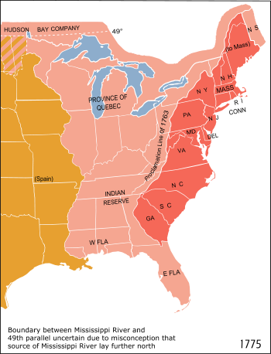**Chapter 5 Concepts: Shaping a New Nation**

**After the American Revolution….**

There is No Central Government in control of the States.

States draft their own Constitutions

States adopted voting policies that varied. They included;

- land owners could vote

-All white men were allowed to vote

**Continental Congress Debates**

**(They need to decide how to manage the government, land, and new states)**

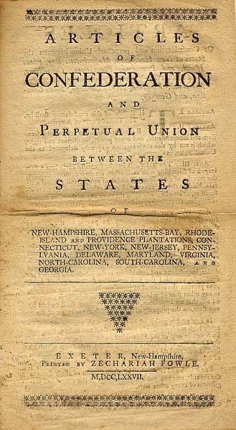

***Articles of Confederation***

-1st Document to share powers of State and Federal Power

|  |  |
| --- | --- |
| **CAN** | **CAN’T** |
| Declare War | No Central Department |
| Make Peace | Collect taxes |
| Sign Treaties | No President |
| Set Money | Protect States from uprising Militia men (Shay’s Rebellion) |
| ***Rules for becoming a state*** |  |
| Postal Service |  |

The articles were Weak

-Voting rights weren’t fair.- Each state’s population was different.

-Congress was in major debt after the war: Could not collect Taxes

-The value of money was different between states.

**Land Ordinances**

-Land Ordinance of 1785- The Land Proclamation of Britain was no longer in existence. We sent out people to survey this land.

-Northwest Ordinance of 1787-Set rules for land claim, setting up states, voting etc.

Shay’s Rebellion

-Farmers were angry at paying their debts after they fought in the Revolution

-1,200 marched to the arsenal to close the courts  
-Town militia reacted and shot 4 farmers.

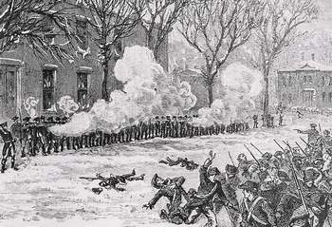

This caught the attention of government leaders because they understood the country hand major problems among the people.

**Drafting/Writing the Constitution**

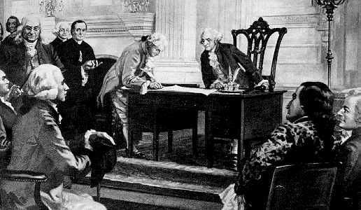

Big States vs. Small States

*James Madison-Virginia Plan:* Representatives based on population

(The House of Represent. Idea)

William Patterson-The Jersey Plan

One House of Congress in which each state had a single vote.

(The Senate Idea)

*Roger Sherman:-The Great Compromise* (An agreement to settle the problem of how to structure representative Government.)

-Equal reps in Senate (2 people for a 6 year term)

-House of Reps: based on Population

**The Population Becomes an Issue for Voting Rights.**

The **Northern** delegates do not want the slaves to be considered in the House of Reps vote because the North didn’t have slaves and it would drive up the South’s population (against the North)

The **South** wants the Number of Slaves to be included in their population since there were not as many whites living there compared to the North.

*The Three-Fifth’s Compromise*

-3/5ths of the state’s slaves to be counted in the population count

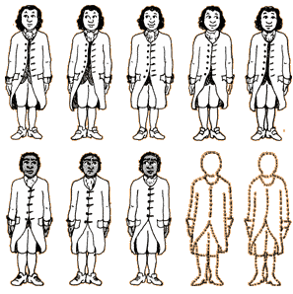

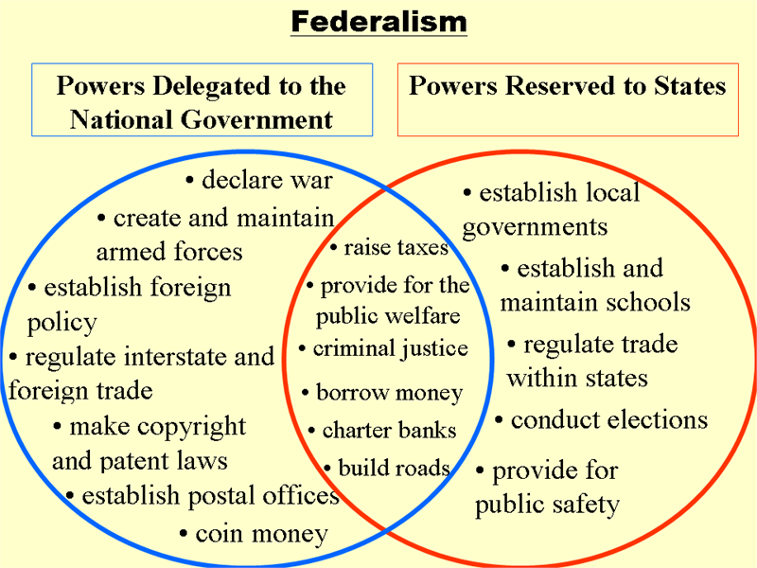

**Federalism:** Divided Power between the National and State Governments

**SYSTEM OF CHECKS AND BALANCES**

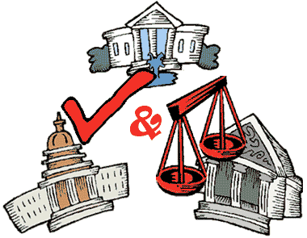

Judicial (Judges) -Supreme court interprets constitutionality of our laws.



Executive: (President) Carry out laws, Veto Bills, Appoints Judges, Pardons, International/Foreign Policy

Legislative (Law) Congress: The Senate and House create laws, pass bills, and allocate funding for initiatives.

**Section 3: RATIFYING THE CONSTITUTION**

Letters from the Federal Farmer:

An anti federalist publication, protected rights should include Freedom of press, religion and trial by jury.

The Federalist: 85 essays printed in NY papers defending the Constitution.

**Anti Federalists:**

Against having a strong central government (against Constitution).

**Federalists:**

Supported the new Constitution’s balance of power between state and national governments.

**Ratification**, or passing of a bill, involved two opposing parties.

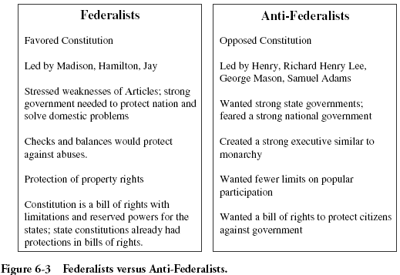

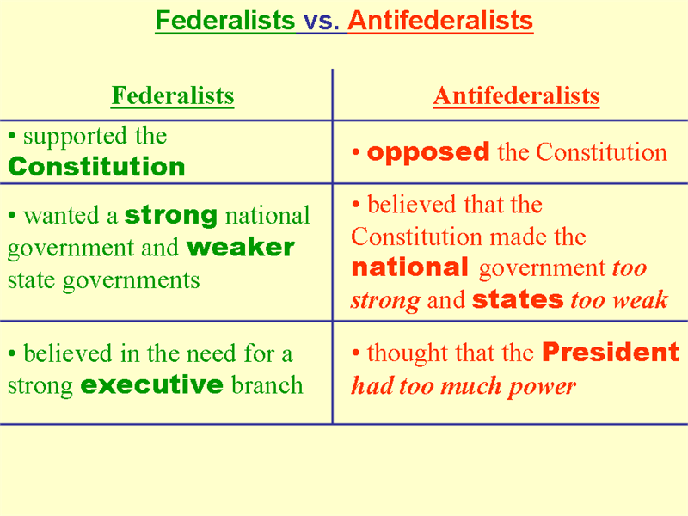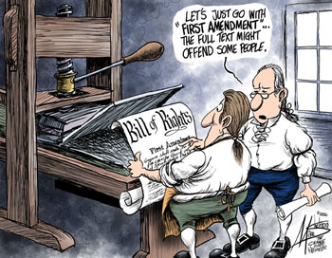In order to pass the Constitution, The Anti Federalists insisted the Rights of the people in the state.

Bill of Rights

-The First 10 Amendments (laws) protecting citizens’ rights.