sheName:

1. Which river system is found in Mesopotamia?
   * 1. Nile River
     2. Yellow River
     3. Tigris and Euphrates rivers
     4. Ganges and Brahmaputra rivers

*Base your answer to question 2 on the chart below and on your knowledge of social studies.*

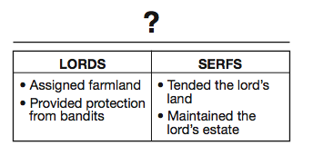

1. What is the best title for this chart?
   * 1. Role of the Church
     2. Feudal Obligations
     3. Knights’ Code of Chivalry
     4. Rules for Guild Membership
2. Which culture is credited with the development of gunpowder, the abacus, and the compass?

(1) Chinese (3) Indian

(2) Persian (4) Japanese

1. • Cyrillic alphabet adopted for use in Russia.

• Russians accepted the teachings of the Orthodox Christian Church.

• Onion-shaped domes dotted the skyline of Kievan Russia.

Which term is most closely associated with these statements?

(1) ethnocentrism (3) cultural diffusion

(2) interdependence (4) colonialism

1. Which achievements are most closely associated with the Golden Age of Islamic culture?
   * 1. mosques, medical books, and algebra
     2. gunpowder, pagodas, and silk
     3. aqueducts, roads, and polytheistic temples
     4. columns, theory of a sun-centered universe, and democracy
2. Followers of which religion engage in these practices?

• Fasting during Ramadan

• Praying five times each day

• Giving charity to the poor

(1) Christianity (3) Islam

(2) Buddhism (4) Judaism

1. Which achievements are most closely associated with the Golden Age of Islamic culture?
   * 1. mosques, medical books, and algebra
     2. gunpowder, pagodas, and silk
     3. aqueducts, roads, and polytheistic temples
     4. columns, theory of a sun-centered universe, and democracy
2. What was a direct result of the Black Death in Europe?
   * 1. The rate of urbanization increased.
     2. A shortage of workers developed.
     3. Food crops had to be imported from the Americas.
     4. German states dominated trade in the eastern Mediterranean.
3. Which geographic feature did the earliest civilizations in Egypt, India, and China have in common?
   * 1. mountains that provided protection from invasion
     2. rivers that increased the fertility of the land by flooding
     3. vast forests that supplied lumber for building
     4. tropical climates that included monsoons

*Base your answers to questions 10 and 11 on the map below and on your knowledge of social studies.*

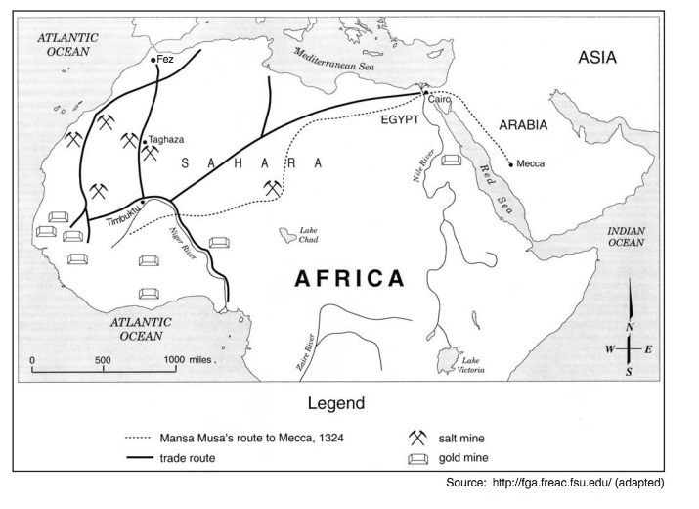

1. Which statement about the trip taken by Emperor Mansa Musa is accurate?
   * 1. The trip extended beyond North African trade routes.
     2. Mansa Musa used the Mediterranean Sea to reach Mecca.
     3. The route primarily followed major rivers.
     4. Mansa Musa traveled to Fez on his way to Mecca.
2. Which conclusion about trade is best supported by the information on this map?
   * 1. Timbuktu was a center of trade in West Africa.
     2. The Sahara Desert prevented trade.
     3. Cairo and Mecca were trading partners.
     4. Mansa Musa did not visit Arabia.

*Base your answer to question 12 on the quotation below and on your knowledge of social studies.*

…We give our obedience to those whom we put in positions of authority, and we obey the laws themselves, especially those which are for the protection of the oppressed, and those unwritten laws which it is an acknowledged shame to break.…”

Pericles, quoted in History of the Peloponnesian War

1. In this quotation, Pericles is praising Athenian
   * 1. civic values
     2. artistic creativity
     3. military strengths
     4. commercial success
2. What is a primary characteristic of a feudal society?
   * 1. a representative government
     2. economic equality for all
     3. protection of individual rights
     4. an exchange of land for services
3. Believers of Hinduism are expected to
   * 1. fulfill their dharma for a favorable reincarnation
     2. complete a pilgrimage to Mecca
     3. obey the Ten Commandments
     4. follow the Eightfold Path to achieve enlightenment
4. One long-term effect of the Crusades was the
   * 1. development of Pax Mongolia
     2. fall of the Ming dynasty
     3. control of Jerusalem by Europeans
     4. growth of trade and towns in western Europe
5. Which achievements are most closely associated with the Tang and Song dynasties of China?
   * 1. wheel and stirrup
     2. chinampas and calendar
     3. gunpowder and movable wooden type
     4. mosaics and domes
6. Korea has frequently served as a cultural bridge between
   * 1. Cambodia and Vietnam
     2. Russia and India
     3. Thailand and Indonesia
     4. China and Japan
7. What is one way in which animism, Shinto, and Daoism are similar?
   * 1. emphasis on harmony with nature
     2. monotheistic belief systems
     3. belief in the idea of nirvana
     4. reliance on the teachings of the Vedas

*Base your answer to question 19 on the photographs below and on your knowledge of social studies.*

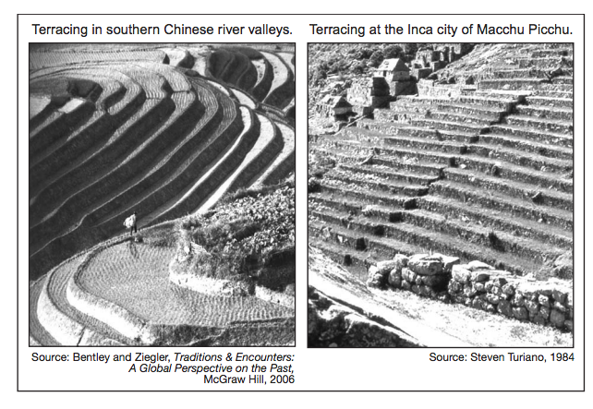

1. These photographs indicate the people of China and the people of ancient Peru modified their environment to
   * 1. create effective trade routes
     2. increase the amount of land available for agriculture
     3. move large quantities of water into cities
     4. provide an effective defense
2. Which institution served as the primary unifying force in medieval western Europe?

(1) legislature (3) monarchy

(2) church (4) military

1. Which philosophy is most closely associated with the development of the Chinese civil service system?

(1) legalism (3) Daoism

(2) Buddhism (4) Confucianism

*Base your answer to question 22 on the illustration below and on your knowledge of social studies.*

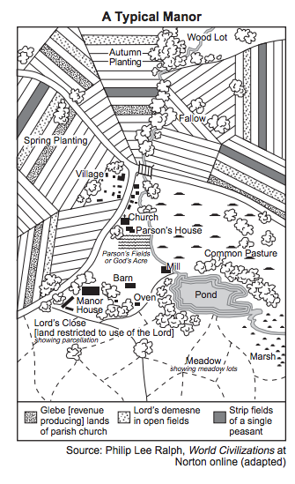

1. What does this illustration show about a typical manor?
   * 1. All residents were treated equally.
     2. Secular values in society were stressed.
     3. There were a large number of factories.
     4. People depended on agricultural production
2. The leadership of Genghis Khan, the use of the stirrup, and excellent horsemanship skills all contributed directly to the
   * 1. collapse of Silk Road trade
     2. defeat of Tokugawa Japan
     3. beginning of European exploration
     4. rise of the Mongol Empire
3. • If a son has struck his father, they shall cut off his hand.

• If a seignior has destroyed the eye of a member of the aristocracy, they shall destroy his eye.

• If he has broken another seignior’s bone, they shall break his bone.

Which document contains these statements?

* + 1. Ten Commandments
    2. Code of Hammurabi
    3. Edicts of Asoka
    4. Twelve Tables

1. Which development is most closely associated with the beginning of the Byzantine Empire?
   * 1. emergence of the Russian Orthodox Church
     2. division of the Roman Empire
     3. building of the Hagia Sophia
     4. fall of Constantinople
2. Which geographic feature has helped isolate China?
   * 1. Andes Mountains
     2. Kalahari Desert
     3. Himalaya Mountains
     4. Great Rift Valley
3. The rule of Shi Huangdi, legalism, and the tomb of terra cotta soldiers are most closely associated with the

(1) Maurya Empire (3) Persian Empire

(2) Qin dynasty (4) Hellenistic culture

1. • Creation of the House of Wisdom in Baghdad

• Development of algebra

• Use of calligraphy as an art form

Which Golden Age is most closely associated with these achievements?

(1) Islamic (3) Tang

(2) Gupta (4) Songhai

1. The development of which early civilization was influenced most directly by the Tigris River, the Zagros Mountains, and the Syrian Desert?

(1) Chinese (2) Egyptian (3) Maya (4) Mesopotamian

1. Which religion includes the Four Noble Truths, the Eightfold Path, and nirvana?

(1) Buddhism (3) Judaism

(2) Hinduism (4) Christianity

1. Marco Polo and Ibn Battuta are best known for
   * 1. exploring the Western Hemisphere
     2. leading religious movements
     3. opening trade between Africa and Japan
     4. providing extensive information about lands and people

*Base your answer to question 32 on the photographs below and on your knowledge of social studies.*

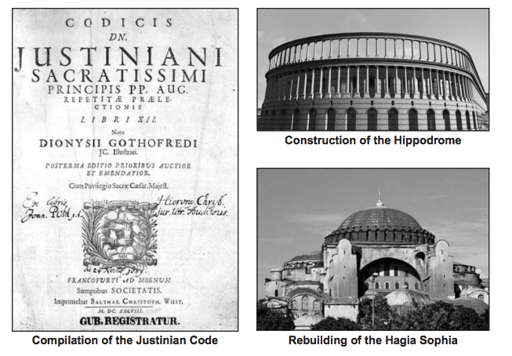

1. The cultural contributions shown in these photographs were developed during the

(1) Mesopotamian civilizations (3) Tang dynasty

(2) Pax Romana (4) Byzantine Empire

1. The bubonic plague affected economic development in medieval times by
   * 1. encouraging the introduction of new types of crops
     2. causing production to decline and prices to rise
     3. sparking the ideas of socialism and reform
     4. destroying the guild system
2. An economic reason for the institution of serfdom was to maintain
   * 1. an educated citizenry
     2. a stable workforce
     3. overseas trade
     4. religious uniformity
3. The Neolithic Revolution is often considered a turning point in history because
   * 1. city dwellers learned to control fire
     2. societies became more nomadic
     3. nuclear families evolved into extended families
     4. permanent settlements developed in river valleys
4. Filial piety and the five relationships are most often associated with

(1) Hinduism (3) animism

(2) Daoism (4) Confucianism

*Base your answer to question 37 on the map below and on your knowledge of social studies.*

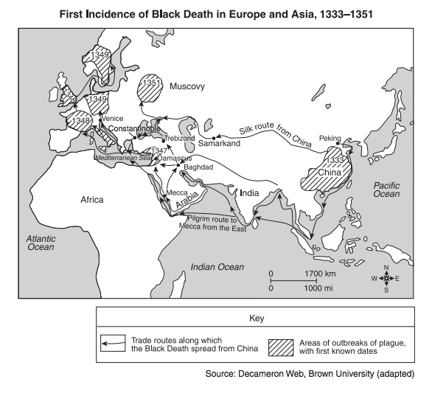

1. The information on this map suggests that the Black Death was primarily spread by the actions of

(1) invading armies (3) merchants

(2) nomadic peoples (4) explorers

1. The best definition of subsistence agriculture is
   * 1. supplying crops for overseas exports
     2. bartering crops for manufactured goods
     3. storing surplus food in case of famine
     4. producing just enough food for a family’s use
2. Which geographic feature most directly influenced the development of Greek city-states?

(1) deserts (3) vast plains

(2) mountainous terrain (4) monsoons

1. • Stained glass windows assist people in understanding Biblical stories.

• Taller and larger cathedrals emphasize the grandeur and glory of God.

These statements best describe elements of

1. the Four Noble Truths
2. Chinese pagodas
3. Gothic architecture
4. Greek ideas
5. Which heading best completes the partial outline below?
   * + 1. _________________________________
          1. Cities
          2. Complex government
          3. Job specialization
          4. Writing system
6. Examples of Early Technology
7. Results of Cultural Diversity
8. Characteristics of Civilizations
9. Causes for the Neolithic Revolution
10. • Preserved Hindu traditions

• Produced fine poems and drama

• Made advances in mathematics, science, and medicine

These achievements refer to contributions of the

(1) Gupta Empire (3) Greek city-states

(2) Persian Empire (4) Tang dynasty

1. The concept of zero, the expansion of the caste system, and the creation of the decimal system are most closely associated with the

(1) Inca Empire (3) Song dynasty

(2) Tokugawa shogunate (4) Gupta Empire

1. One way in which The Epic of Gilgamesh, The Odyssey, and The Mah¯abh¯arata are similar is that they are
   * 1. sets of written legal principles that spell out the rights of citizens
     2. stories that are tied to monotheistic religious beliefs
     3. paintings that depict heroes and cultural values
     4. works of literature that give historians information about early civilizations
2. Which title best completes the partial outline below?
   * + 1. _________________________________
          1. Located in a region of volcanoes and earthquakes
          2. Has limited mineral resources
          3. Concentration of population in coastal plains
3. Geographic Features of Japan
4. Environmental Challenges in Mongolia
5. Economic Issues Facing Saudi Arabia
6. Factors Affecting British Industrialization
7. During the European Middle Ages, guilds were created to
   * 1. obtain better working conditions in factories
     2. standardize goods and prices
     3. regulate the money supply
     4. increase competition
8. Which Neolithic Revolution development led to the other three?
   * 1. complex civilizations
     2. surplus of food
     3. division of labor
     4. domestication of plants and animals
9. • The Ganges River is sacred to people practicing Hinduism.

• Shinto shrines are usually located near mountains or lakes.

• The Jordan River is a site of many Christian baptisms.

Which conclusion is most valid based on these statements related to belief systems?

* + 1. The Middle East was the birthplace of these belief systems.
    2. Water plays an important role in these belief systems.
    3. Pilgrimages to mountainous regions are encouraged by these belief systems.
    4. Understanding nature is a requirement of these belief systems.

1. The Russian Orthodox Church developed as a result of Russia’s cultural interactions with which group?

(1) Byzantines (3) Vikings

(2) Muslims (4) Huns

1. The Indus and Huang He (Yellow) rivers are both closely associated with
   * 1. border disputes
     2. sacred biblical sites
     3. cradles of early civilization
     4. oil discoveries

*Base your answers to questions 19 and 20 on the speakers’ statements below and on your knowledge of social studies.*

**Speaker A**: We must fight to keep control of Jerusalem in the hands of those who believe in Allah.

**Speaker B:** Come and battle while there is still time to protect the Holy Land where Christ walked.

**Speaker C:** We must go forth to heal the split between the churches.

**Speaker D:** An investment in ships and knights will yield control of profitable trade routes.

1. Which speaker expresses a Muslim perspective during the Crusades?

(1) A (2) B (3) C (4) D

1. Which speaker is expressing an economic motive for the Crusades?

(1) A (2) B (3) C (4) D

1. In the European feudal system under manorialism, what is the most significant economic commodity?

(1) livestock (3) gold and silver

(2) land (4) sugar and spices

1. The Neolithic Revolution was a turning point in history because
   * 1. factories began to use assembly-line techniques
     2. new inventions led to overseas exploration
     3. alternatives to hunting and gathering developed
     4. the use of chemical fertilizers increased agricultural production

*Base your answer to question 55 on the map below and on your knowledge of social studies.*

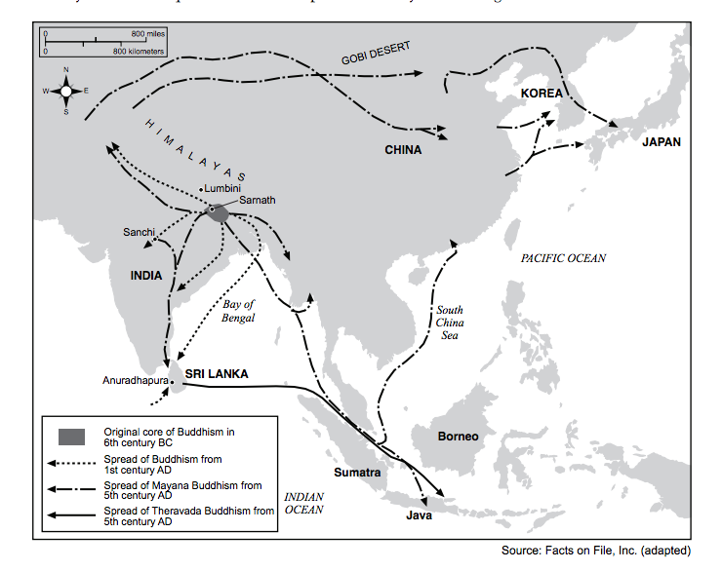

1. Which concept is most closely associated with this map of Asia?

(1) nonalignment (3) colonization

(2) urbanization (4) cultural diffusion

1. Which heading best completes the partial outline below?

I. __________________________________

A. Development of a stable food supply

B. Establishment of permanent settlements

C. Development of writing systems and religions

1. Effects of the Migration of People
2. Results of the Neolithic Revolution
3. Achievements During Feudalism
4. Causes of the Green Revolution in Agriculture
5. Some archaeologists believe the earliest human presence in the Americas is associated with the
   * 1. migration of nomads across the Bering Strait
     2. exploration of the Caribbean by Europeans
     3. movement of tribes during the Bantu migration
     4. journey of traders along the Silk Roads