Nombre__________________________________________La fecha___________________Periodo______

**Unidad 6 Etapa 3: Actividades del verano**

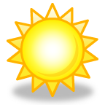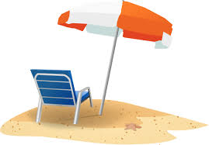

|  |  |
| --- | --- |
| The spa/ beach resort | El balneario |
| The sand | La arena |
| The sea | El mar |
| The wave | La ola |
| The umbrella | La sombrilla |
| The umbrella | El parasol |
| The hammock | La hamaca |
| The foldable chair | La silla plegable |
| The beach towel | La toalla playera |
| The suntan lotion | La crema bronceadora |
| The sunblock | La crema protectora |
| The bathing suit | El traje de baño |
| The swimsuit | El bañador |
| The sunglasses | Los anteojos del sol |
| The water ski | El esquí acuático |
| The small boat | El barquito |
| The snorkel | El buceo |
| The sailboat | La plancha de vela |
| The sandcastle | Un castillo de arena |
| The seashell | La concha del mar |
| The weekend | El fin de semana |
| The pool | La piscina |
| The pool | La alberca |
| The lake | El lago |
| The heat | El calor |
| The sun | El sol |
| The sky | El cielo |
| The wind | El viento |
| The cloud | La nube |
| Tennis | El tenis |
| The tennis court | La cancha de tenis |
| The tennis game | El juego de tenis |
| The ball | La pelota |
| The racquet | La raqueta |
| The golf | El golf |
| The golf course | El campo de golf |
| The golf game | El juego de golf |
| The golf bag | La bolsa de golf |
| The stick | El palo |
| The stick/cane (ski/hockey) | El bastón |
| The bowling pin | La bola |
| The hole | El hoyo |

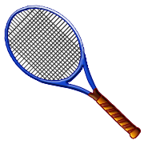****

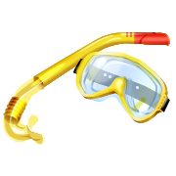**Verbos útiles**

|  |  |
| --- | --- |
| To pass | Pasar |
| To snorkel/ scuba dive | Bucear |
| To swim | Nadar |
| To rent | Alquilar |
| To throw out | Echar |
| To hit | golpear |
| To shine | Brillar |

[http://t1.gstatic.com/images?q=tbn:ANd9GcR1rpub3M7UKMC9uBSjs9exAJt8HZg9lorly6oTxSSo2RgUsA6X:leadershipcriteria.com/wp-content/uploads/6_beach_clipart_border.gifhttp://t1.gstatic.com/images?q=tbn:ANd9GcR1rpub3M7UKMC9uBSjs9exAJt8HZg9lorly6oTxSSo2RgUsA6X:leadershipcriteria.com/wp-content/uploads/6_beach_clipart_border.gif](http://www.google.com/url?sa=i&source=images&cd=&cad=rja&uact=8&docid=3fVILQB-Ph6quM&tbnid=wnYFHzBErx5ZMM:&ved=0CAgQjRw4Mw&url=http://leadershipcriteria.com/beach-clipart&ei=rORGU4fYJpS_sQTTiYLgBA&psig=AFQjCNF1LJgY8gPQNoq4QvJLs6-DBhajVA&ust=1397241388702327)