**TOPIC 5-ENERGY and ENERGY TRANSFER**

To understand energy, you must first understand the phases of matter. Matter is the amount of ‘stuff’ of molecules in a given area. Based on their space and chemical composition, you can have the following;

**[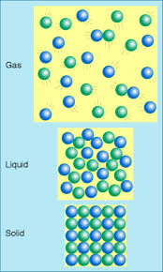](http://www.google.com/url?sa=i&source=images&cd=&cad=rja&docid=ke0-VRxRz3R9nM&tbnid=x5rCfzmlU_JusM:&ved=0CAgQjRw&url=http://myweb.cwpost.liu.edu/vdivener/notes/solid-liquid-gas.htm&ei=87mpUt_5IIXRkQfKnIGIBA&psig=AFQjCNH3VdnatPmKVAAq1ANhDbX5pXgj6w&ust=1386941299594157)Gas:** Molecules are not closely packed together.

-The least dense because molecules are not closely packed together.

**Liquid:** Molecules are more loosely packed together, causing them to be more ‘fluid’ and move.

-Water is less dense than a solid.

**Solid:** molecules are closely packed together.

**There are 3 ways to transfer energy;**

1. 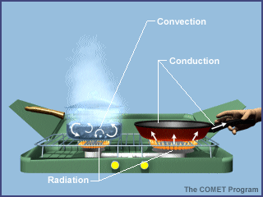Conduction: Transfer of heat in solids. Molecules collide into each other as they are closely packed in a solid.
2. Convection: Transfer of heat energy in air and water.
3. Radiation: Transfer of *energy* ***through*** *any material*.

PHASE CHANGE DIAGRAM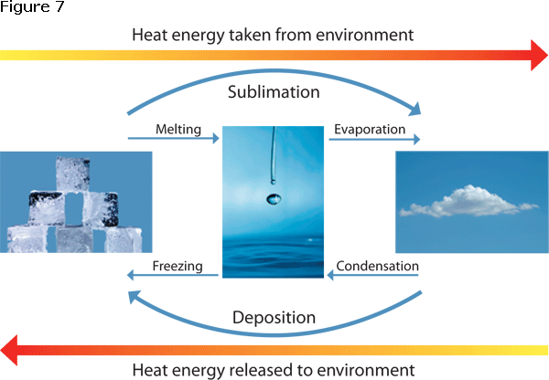

*look at the arrangement of molecules as the temperature increases.

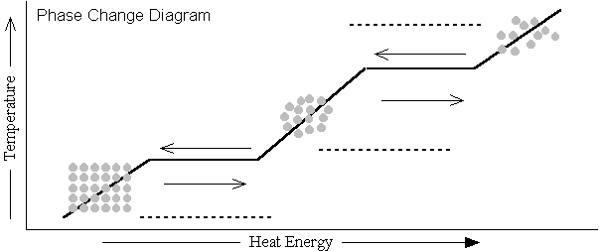

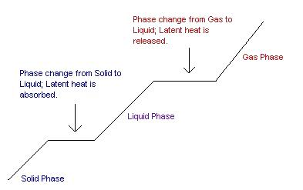

* You must know that you cannot have BOTH a phase change and a Temperature increase. It’s only one or the other.
* Solid, Liquid and Gas involve Kinetic Energy. The molecules are moving because they have already gained the heat.



This is Phase Change. This is Phase Change.

Latent Heat: Energy Latent Heat: Energy

Is being absorbed, or gained. Is being absorbed, or gained

Flat, or a plateau. *Trick: “Latent/Lazy” heat is

*Trick: “Latent/Lazy” heat is

Flat, or a plateau.

* The inclines that go up, or down shows Kinetic Energy. Molecules are moving and heat is being gained.



|  |
| --- |
| Oklahoma Climatological Survey |
| *Properties of Water:*  http://www.regentsearth.com/Illustrated%20ESRT/Page%201%20(Prop%20of%20H2O%20&%20Sp.%20Heat)/Properties%20of%20water.jpg  First, some definitions:  Joule:             A unit of energy (in this case, heat energy). Energy can be added to the water or removed from it.  Melting:          A phase change from solid to liquid. Heat energy must be added to cause melting.  Freezing:         A phase change from liquid to solid. Heat energy must be removed to cause freezing.  Vaporization:   A phase change from liquid to gas (water vapor). Heat energy must be added to cause water to vaporize (evaporate).  Condensation:  A phase change from vapor to liquid. Heat energy must be removed to cause condensation.  Density:           Mass/Volume. The density of water is 1g/ml at 3.98°C. At this temperature water has it's minimum volume.                        If water goes above OR below this temperature it will expand and become less dense. That's why ice floats!  http://www.sciencecases.org/weather_forecasting/fig7.gifNow some facts:  To melt water you must add 334 Joules of heat energy for every gram of ice (solid water) you want to melt.  To freeze water you must remove 334 Joules of heat energy for every gram of liquid water you want to freeze. The law of conservation of energy states: "Energy cannot be created nor destroyed" so if it's removed from the water it must go somewhere else. Often it just goes into the environment.  To vaporize water (make it evaporate) you must add 2260 Joules of heat energy for every gram of water you want to evaporate. Often this heat energy comes from the surface the water is on. If the water is on you, heat energy is transferred from you to the water causing it to evaporate. You lose the heat energy to the water making you cooler. This is why we perspire.  To make water vapor **condense** into liquid water you must remove 2260 Joules of heat energy for every gram of water that condenses. The energy that *is removed* usually enters the environment, the air where the condensation is occurring.  *GO TO THE TEST QUESTIONS ON MY WEBSITE TO PRACTICE!!!  Topic 5: Energy and the Processes. |

|  |  |  |
| --- | --- | --- |
|  | **Heat Transfer** | |
|  |  |  |
|  | **Principle** | The driving force for atmospheric motion is the sun and, in particular, the uneven distribution of solar radiation across the earth. It is the primary job of the atmosphere to redistribute energy in order to achieve a balance from pole to equator. We need to understand methods of heat exchange in the atmosphere to appreciate how the thin atmosphere keeps us alive. |
|  |  |  |
|  | **Energy** | * Energy is the ability or capacity to do work on some form of matter.   There are several forms of energy, including the following:   * 1. Potential energy is the energy which a body possesses as a consequence of its position in a gravitational field (e.g., water behind a dam).   2. Kinetic energy is the energy which a body possesses as a consequence of its motion (e.g., wind blowing across a wind generator). It is dependent upon an object's mass and velocity (e.g., moving water versus moving air).   3. Internal energy is the total energy (potential and kinetic) stored in molecules.   4. Heat (or thermal) energy is kinetic energy due to motion of atoms and molecules. It is energy that is in the process of being transferred from one object to another because of their temperature difference.   5. Radiant energy is the energy that propagates through space or through material media in the form of electromagnetic radiation.      * The First Law of Thermodynamics states that energy lost during one process must equal the energy gained during another. |

http://okfirst.mesonet.org/train/meteorology/HeatTransfer.html