Name:_________________________________________ CSI/Chapter 3 – Section 3.2

In Exercises 1 through 6, describe the contents of the text box after the button is clicked.

**1.** Private Sub btnOutput_Click(...) Handles btnOutput.Click

txtBox.Text = "Hello"

End Sub

**2.** Private Sub btnOutput_Click(...) Handles btnOutput.Click

txtBox.ForeColor = Color.Red

txtBox.Text = "Hello"

End Sub

**3.** Private Sub btnOutput_Click(...) Handles btnOutput.Click

txtBox.BackColor = Color.Orange

txtBox.Text = "Hello"

End Sub

**4.** Private Sub btnOutput_Click(...) Handles btnOutput.Click

txtBox.Text = "Goodbye"

txtBox.Text = "Hello"

End Sub

**5.** Private Sub btnOutput_Click(...) Handles btnOutput.Click

txtBox.Text = "Hello"

txtBox.Visible = False

End Sub

**6.** Private Sub btnOutput_Click(...) Handles btnOutput.Click

txtBox.BackColor = Color.Yellow

txtBox.Text = "Hello"

End Sub

In Exercises 7 through 10, assume that the three objects on the form were created in the order txtFirst, txtSecond, and lblOne. Determine the output displayed in lblOne when the program is run and the Tab key is pressed. Note: Initially, txtFirst has the focus.

**7.** Private Sub txtFirst_Leave(...) Handles txtFirst.Leave

lblOne.ForeColor = Color.Green

lblOne.Text = "Hello"

End Sub

**8.** Private Sub txtFirst_Leave(...) Handles txtFirst.Leave

lblOne.BackColor = Color.White

lblOne.Text = "Hello"

End Sub

**9.** Private Sub txtSecond_Enter(...) Handles txtSecond.Enter

lblOne.BackColor = Color.Gold

lblOne.Text = "Hello"

End Sub

**10.** Private Sub txtSecond_Enter(...) Handles txtSecond.Enter

lblOne.Visible = False

lblOne.Text = "Hello"

End Sub

In Exercises 11 through 16, determine the errors.

**11.** Private Sub btnOutput_Click(...) Handles btnOutput.Click

Form1.Text = "Hello"

End Sub

**12.** Private Sub btnOutput_Click(...) Handles btnOutput.Click

txtBox.Text = Hello

End Sub

**13.** Private Sub btnOutput_Click(...) Handles btnOutput.Click

txtFirst.ForeColor = Red

End Sub

**14.** Private Sub btnOutput_Click(...) Handles btnOutput.Click

txtBox = "Hello"

End Sub

**15.** Private Sub btnOutput_Click(...) Handles btnOutput.Click

txtBox.Font.Size = 20

End Sub

**16.** Private Sub btnOutput_Click(...) Handles btn1.Click, btn2.Click

Me.Color = Color.Yellow

End Sub

In Exercises 17 through 23, write a line (or lines) of code to carry out the task.

**17.** Display "E.T. phone home." in lblTwo.

**18.** Display "The stuff that dreams are made of." in red letters in txtBox.

**19.** Display "Life is like a box of chocolates." in txtBox with blue letters on a gold background.

**20.** Change the words in the form's title bar to "Hello World."

**21.** Make lblTwo disappear.

**22.** Change the color of the letters in lblName to red.

**23.** Give the focus to txtBoxTwo.

**Name:_________________________________________________ CSI/Chapter 3 – Section 3.2**

**SECTION 3.2 – LAB:** In Exercises 24 through 29, the interface and initial properties are specified. Write the program to carry out the stated task.

**24.** When one of the three buttons is pressed, the words on the button are displayed in the

text box with the stated alignment. (Note: Rely on IntelliSense to provide you with the

proper settings for the TextAlign property.)



|  |  |  |
| --- | --- | --- |
| **Object** | **Property** | **Setting** |
| frmAlign | Text | Text Alignment |
| txtBox | ReadOnly | True |
| btnLeft | Text | Left Justify |
| btnCenter | Text | Center |
| btnRight | Text | Right Justify |

**25.** When one of the buttons is pressed, the face changes to a smiling face (Wingdings

character "J") or a frowning face (Wingdings character "L").



|  |  |  |
| --- | --- | --- |
| **Object** | **Property** | **Setting** |
| frmFace | Text | Face |
| lblFace | Font Name | Wingdings |
|  | Font Size | 24 |
|  | Text | **K** |
| btnSmile | Text | Smile |
| btnFrown | Text | Frown |

26. Pressing the buttons alters the background and foreground colors in the text box.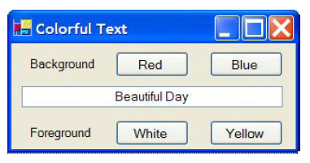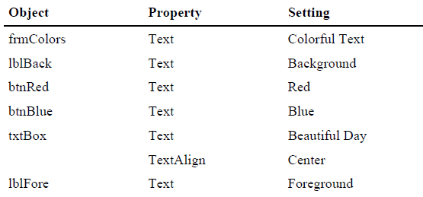

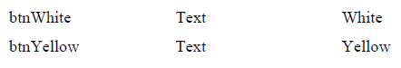

27. When the user moves the focus to one of the three small text boxes at the bottom of the

form, an appropriate saying is displayed in the large text box. Use the sayings "I like life,

it's something to do."; "The future isn't what it used to be."; and "Tell the truth and run."

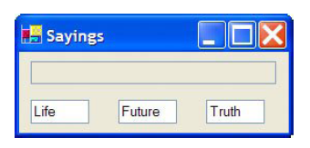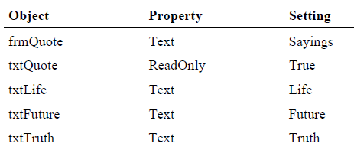

28. Simulate a traffic light with three small square text boxes placed vertically on a form.

Initially, the bottom text box is solid green and the other text boxes are dark gray. When

the Tab key is pressed, the middle text box turns yellow and the bottom text box turns

dark gray. The next time Tab is pressed, the top text box turns red and the middle text

box turns dark gray. Subsequent pressing of the Tab key cycles through the three colors.

Hint: First, place the bottom text box on the form, then the middle text box, and finally

the top text box.

29. The form contains two text boxes into which the user types information. When the user

clicks on one of the text boxes, it becomes blank and its contents are displayed in the

other text box. Note: A text box can be cleared with the statement txtBox.Clear() or

the statement txtBox.Text = "".