CS II-Chapter 6 – EXTRA CREDIT LAB

Least-Squares Approximation. The table below shows the 1988 prices of a gallon of gasoline and the amounts of fuel consumed for several countries. The figure below displays the data as points in the *xy* plane. For instance, the point with coordinates (1, 1400) corresponds to the USA. The figure also shows the straight line that best fits these data in the least-squares sense. (The sum of the squares of the distances of the 11 points from this line is as small as possible.) In general, if(*x*1,*y*1),(*x*2,*y*2), ...,(xn,yn) are *n* points in the *xy* coordinate system, then the least-squares approximation to these points is the line *y*=m*x*+b,where

and

Write a program that calculates and displays the equation of the least-squares line. The program should then allow the user to enter a gasoline price and use the equation of the line to predict the corresponding consumption of fuel. (Place the numeric data from the table in a text file.) A sample run is shown below.

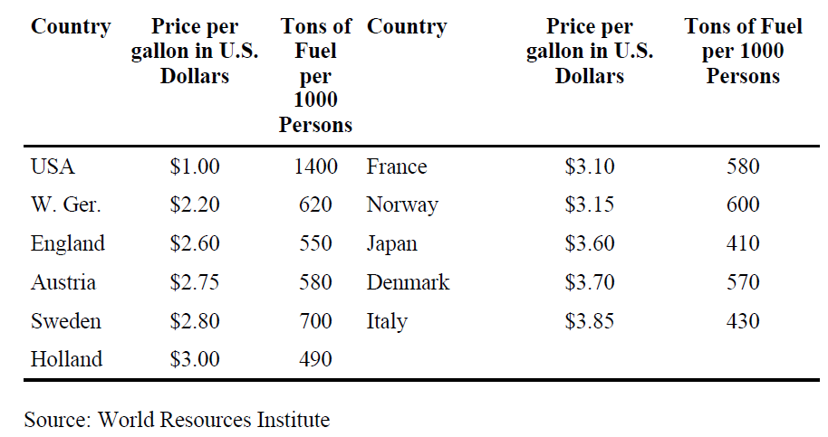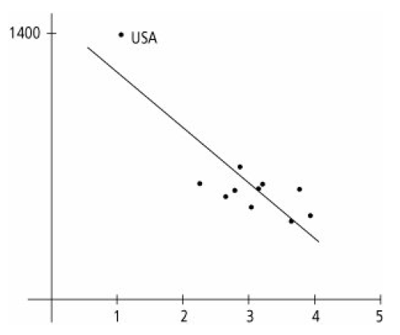

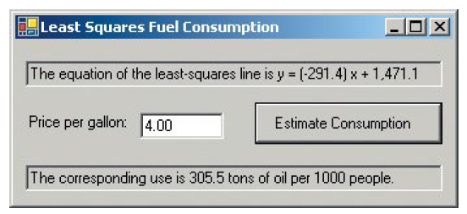

The Twelve Days of Christmas. Each year, PNC Advisors of Pittsburgh publishes a Christmas price list. See the table given below. Write a program that requests an integer from 1 through 12 and then lists the gifts for that day along with that day's cost. On the nth day, the n gifts are 1 partridge in a pear tree, 2 turtle doves, ..., n of the nth item. The program also should give the total cost of all twelve days. As an example, below shows the

output in the list box when the user enters 3.

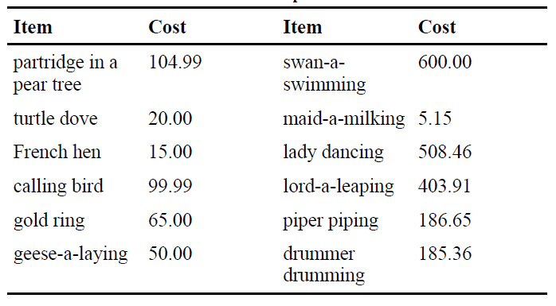

The gifts for day 3 are

1 partridge in a pear tree

2 turtle doves

3 french hens

Cost: $189.99

Total cost for the twelve days: $72,608.00