Specific Heat | Amount of energy needed to raise the temperature of something one degree. | 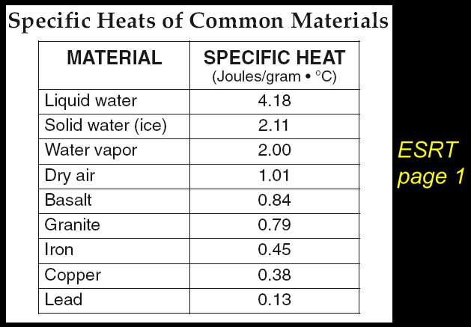
Water | ***Has the highest specific heat. | 4.18 Joules per gram
Closed Energy System | A system that does not release, or lose, energy  -very difficult  To do | 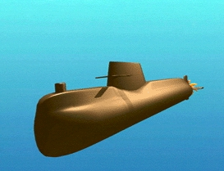  A sub lets out the least amount of energy
Open System | Lets energy escape | 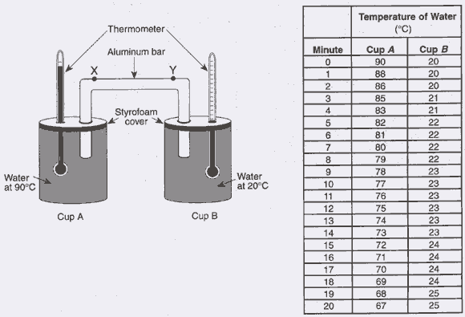
Source to Sink | Energy always moves from it’s source to a cooler place | 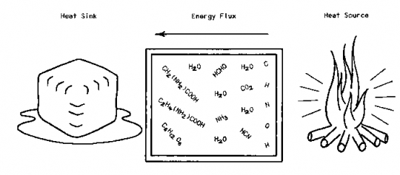
3 ways to transfer energy | - Conduction  - Convection  - Radiation | 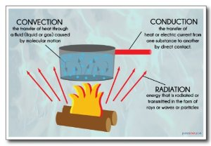
Conduction | Transfer of energy through SOLIDS  -atoms collide with each other | 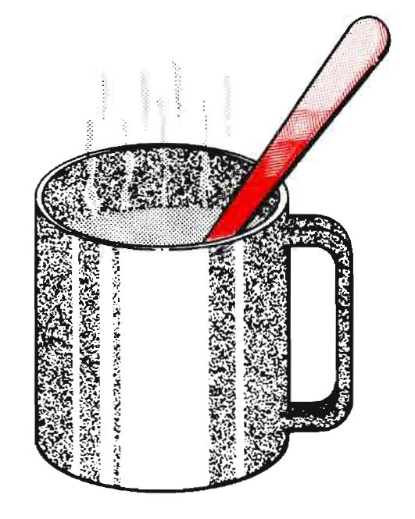
Convection | -transfer of energy in LIQUIDS and GASES | 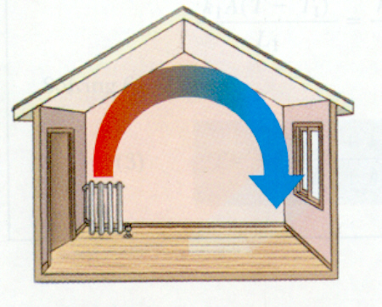
Radiation | -Energy waves transfer through ALL MATERIALS | 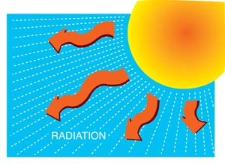
Crest of a wave | Top part of a wave | 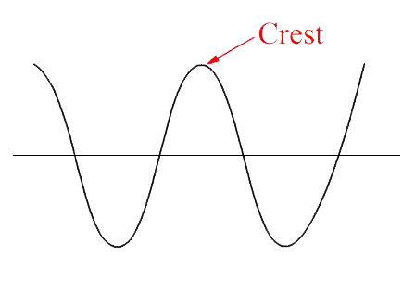
Trough | The bottom of the wave | 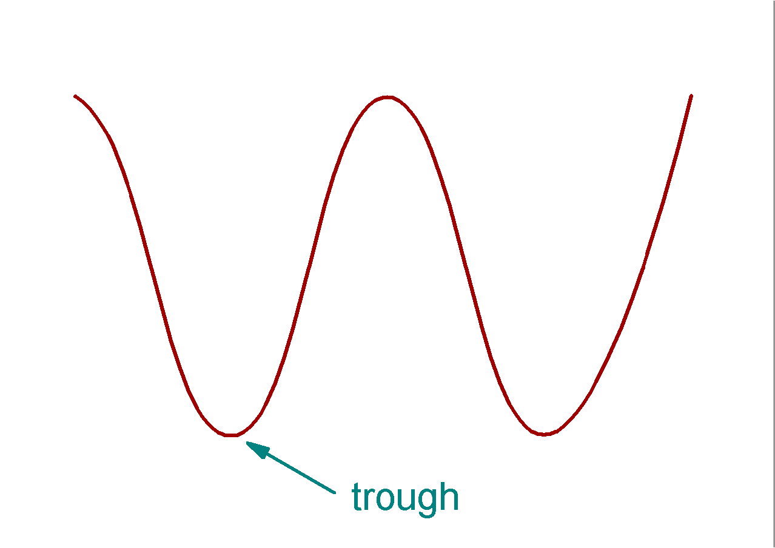
Wavelength | The distance between two Crests or two troughs. | 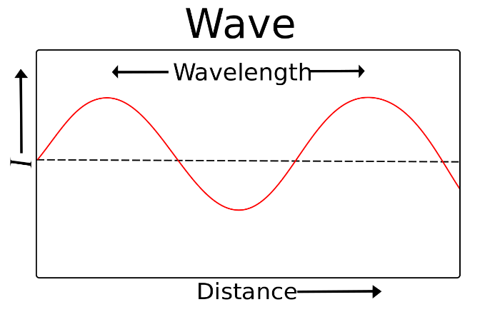
Longitudinal Wave | displacement of the medium is in the same direction as | 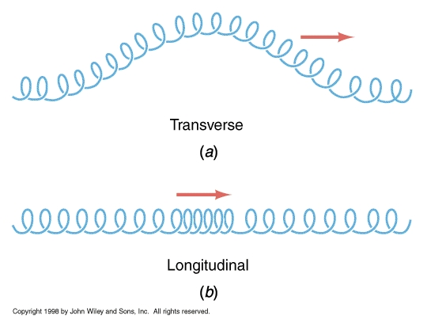
Transverse Waves | The wave moves in a perpendicular direction to the molecules
Amplitude | Height of a  wave | 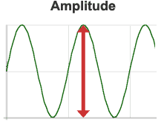
Reflection | Light bounces off.  -no energy absorbed  -light, smooth surfaces reflect best | 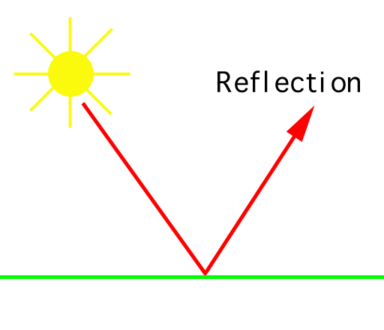
Scatter | Wavelengths move in different directions | 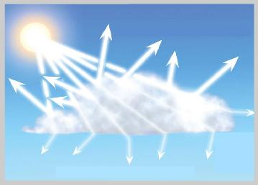
Absorb | Energy is taken in  -dark surfaces  -rough surfaces | 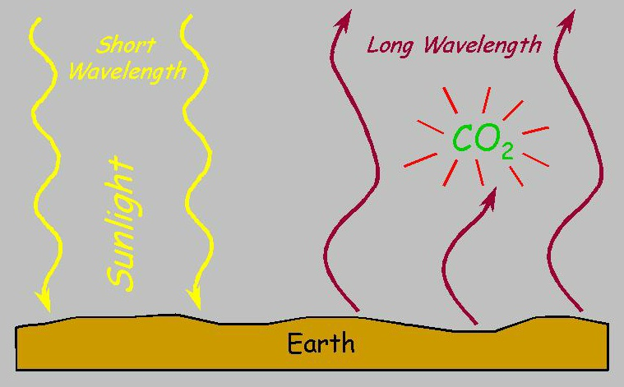
Insolation | In coming  Solar radiation  -energy waves coming from the sun | 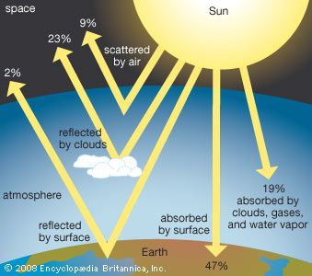
Refraction | Light energy is bent  -based on the object energy is moving through. | 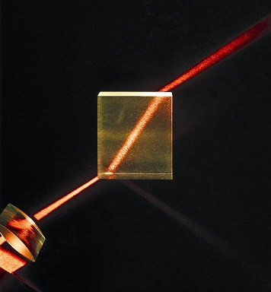
Potential Energy | Stored energy  -not in motion | 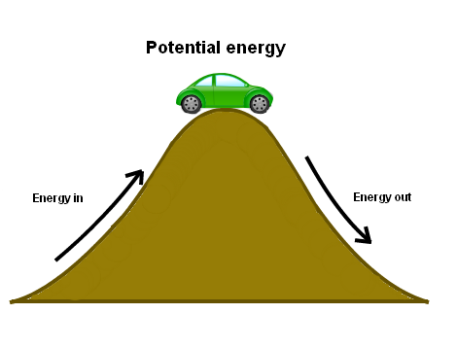
Kinetic Energy | Energy in motion | 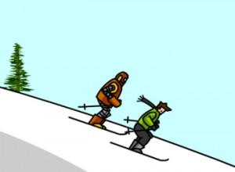
Latent Heat | heat absorbed or radiated during a change of phase at constant temperature and pressure | 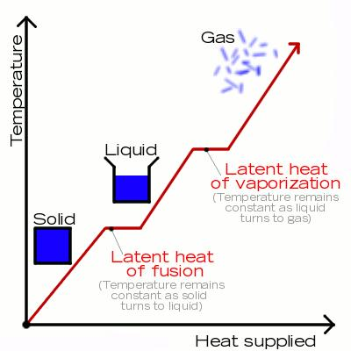
Sublimation | When a substance changes from Solid to gas  Or  Gas to solid | 
Temperature | The measure of how much kinetic energy is in a particle | 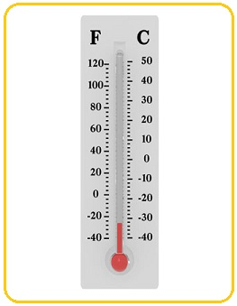
Temperature Scales | 3 ways to measure temperature  - Farenheit  - Centigrade  - Kelvin | 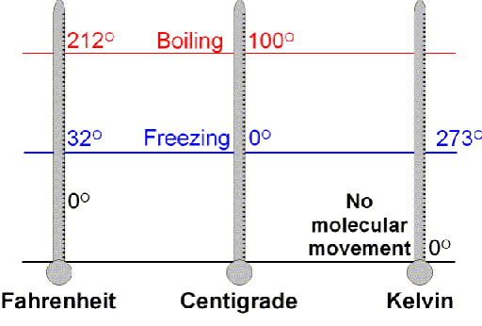
Phase Diagram | Shows all the phase changes of matter related to temperature and heat energy | 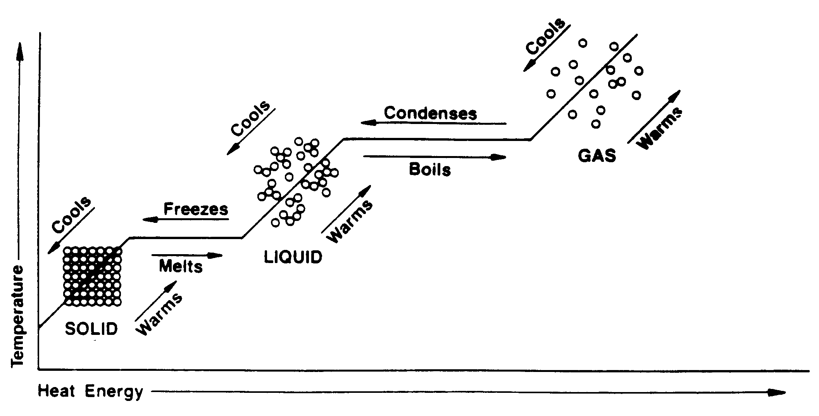
Global Warming | Steady increase of Earth’s average temperature | 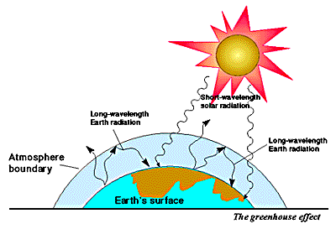
Greenhouse Effect | -Caused by Carbon Dioxide | 