Name:____________________________________________________________ 2-D array practice Questions

In Exercises 1 through 8, determine the output displayed when the button is clicked. All Dim statements

for arrays are in the Declarations section of the Code window.

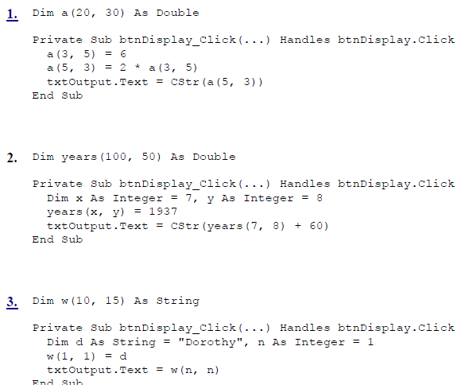

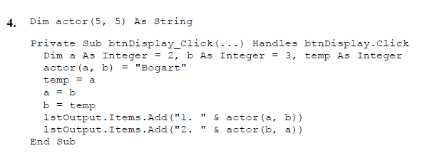

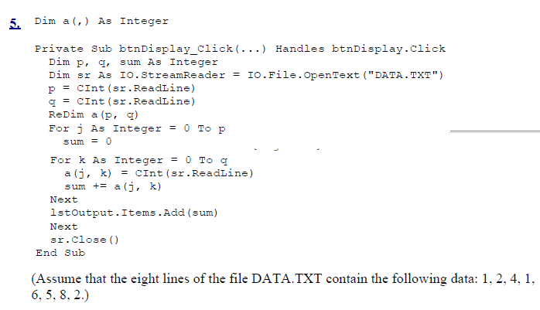

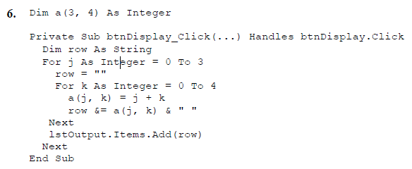

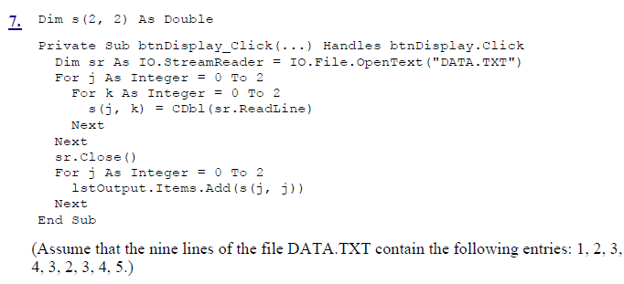

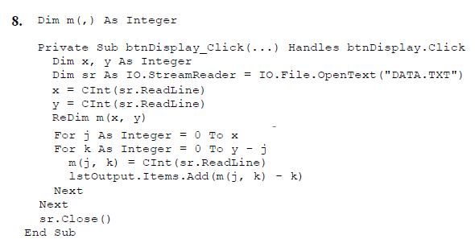

**15**. A company has two stores (1 and 2), and each store sells three items (1, 2, and 3). The

following tables give the inventory at the beginning of the day and the amount of each item sold during that day.

**Beginning Inventory Sales for Day**

**ITEM ITEM**

* + - 1. 2 3 1 2 3

**Store** 1 25 64 23 **Store** 1 7 45 11

* + - 1. 12 82 19 2 4 24 8
  1. Record the values of each table in an array.
  2. Adjust the values in the first array to hold the inventories at the end of the day and display these new inventories.
  3. Calculate and display the number of items in each store at the end of the day.

**18.** Table 7.14 gives the 2002 and 2003 U.S. sales for the five top restaurant chains.

1. Place the data into an array.
2. Calculate the total change in sales for these five restaurant chains.

**Table 7.14. Top restaurant chains.**

|  |  |  |
| --- | --- | --- |
|  | **2002 Sales $MM** | **2003 Sales $MM** |
| 1. McDonald's | 20.3 | 22.1 |
| 2. Burger King | 8.7 | 7.9 |
| 3. Wendy's | 7.1 | 7.5 |
| 4. Subway | 5.2 | 5.7 |
| 5. Taco Bell  Source: QSR Magazine, | 5.2 Dec. 2004 | 5.3 |

**22.** The table below gives the monthly precipitation for a typical Nebraska city during a five-year period. Write a program that reads the table from a text file into an array and then

Displays the output in a list box.



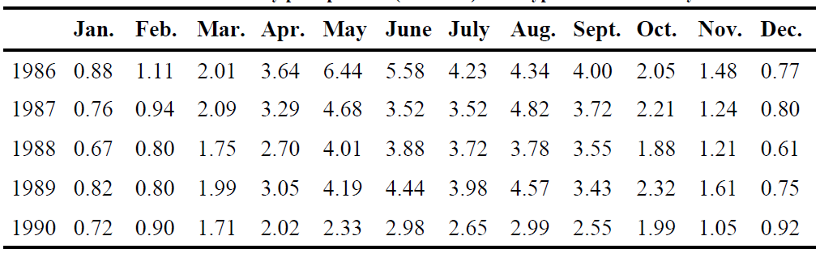

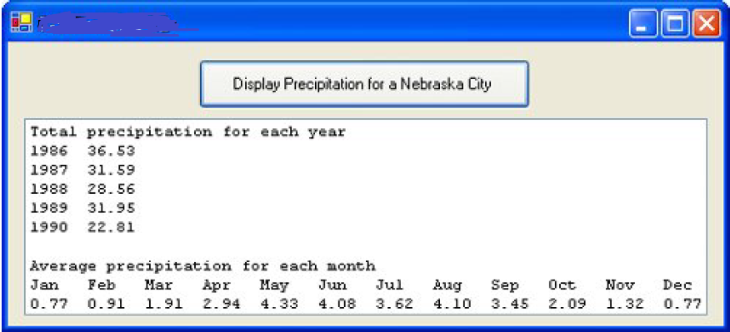

**24**. An n-by-n array is called a magic square if the sums of each row, each column, and each diagonal are equal. Write a program to determine if an array is a magic square and use it to determine if either of the following arrays is a magic square. Hint: If, at any time, one of the sums is not equal to the others, the search is complete.

**a.** 1 15 15 4

12 6 7 9

8 10 11 5

13 3 2 16

**b**. 11 10 4 23 17

18 12 6 5 24

25 19 13 7 1

2 21 20 14 8

9 3 22 16 15