Name_____________________ Math9
Math Terms I need to know!!!
terms | meaning | picture
Domain | x-values, left to right | 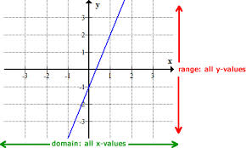
Range | y-values, bottom to top | 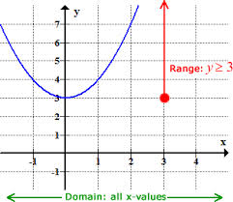
Open circle | Goes with -parenthesis ()  Less then <  Greater then > | 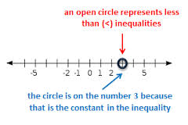
Closed circle | Goes with-  brackets [ ]  less then or equal to  greater then or equal to | 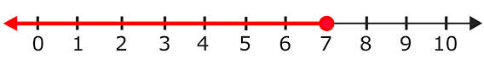
Y > 0 | Means for what X values is y positive | 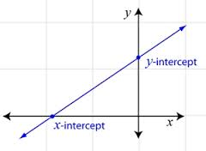
Y < 0 | Means for what x values is y negative | 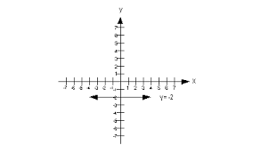
Increasing/decreasing | Read from left to right  Use brackets [ ]Or parenthesis ( ) | 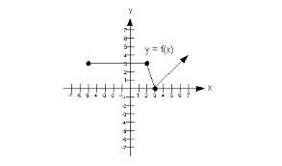
Relative max | A number value or a point (x,y) where a graph reaches a maximum relative to what you see. | 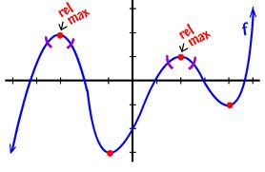
Absolute minimum | You have a lowest point y is 0 not positive | 