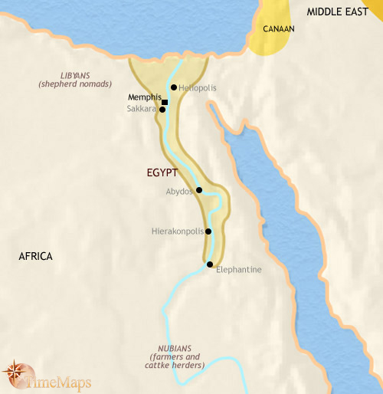**Global History-9**

Directions: Use “RASCA” to develop proof of a civilization. Explain what each one means and why it is important.

|  |  |
| --- | --- |
| **R**ecord Keeping |  |
| **A**dvanced Technology |  |
| **S**pecializations (jobs) | - |
| **C**omplexInstitutions  -Religion  -Government  -Schools |  |
| **A**rchitecture |  |
| Possible Questions  Do you believe Ancient Egypt Qualified as a civilization? Explain. |  |