[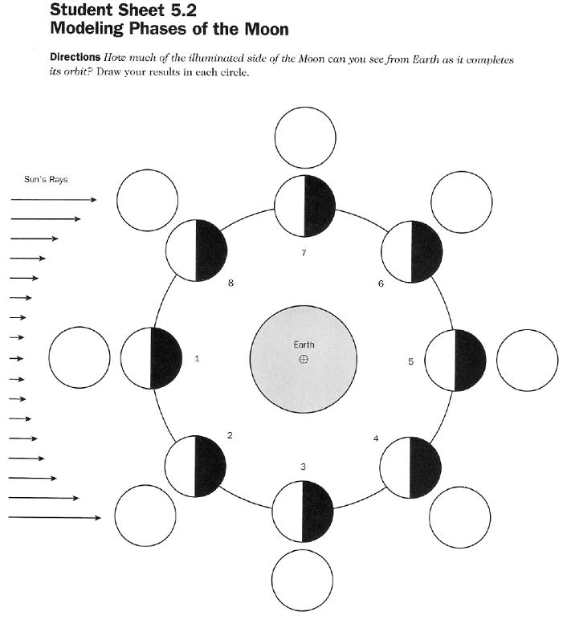](http://www.google.com/url?sa=i&rct=j&q=&esrc=s&source=images&cd=&cad=rja&uact=8&ved=0CAcQjRxqFQoTCPHHsIKm0cgCFcJsPgod3TMDEA&url=http://abcawesomepix.com/blank%2Bmoon%2Bphase%2Bdiagram&psig=AFQjCNGfLieJgOWFfE5qcZKKNA_GVYGhAg&ust=1445438856904646)

[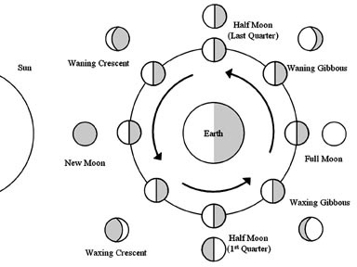](http://www.google.com/url?sa=i&rct=j&q=&esrc=s&source=images&cd=&cad=rja&uact=8&ved=0CAcQjRxqFQoTCJiK7eal0cgCFYV7Pgodjj0OqQ&url=http://www.mrsciguy.com/EarthScience/astro.html&psig=AFQjCNGfLieJgOWFfE5qcZKKNA_GVYGhAg&ust=1445438856904646)