Name:

1. Enlightenment thinkers encouraged the improvement of society through the
   1. teachings of the church
   2. use of reason
   3. development of absolutism
   4. establishment of a rigid social hierarchy
2. “Angry Mob Destroys Bastille”

“Robespierre’s Execution Ends Reign of Terror”

“Napoleon Seizes Power”

Which country’s revolution is referred to in these headlines?

* 1. Spain (3) France
  2. Austria (4) Russia

1. The slogan “Blood and Iron” and a united Germany are most closely associated with
   1. Prince Metternich (3) Camillo Cavour
   2. Simón Bolívar (4) Otto von Bismarck
2. Which pair of natural resources were used to change transportation and manufacturing in Great Britain during the Industrial Revolution?
   1. gold and salt
   2. diamonds and petroleum
   3. copper and tin
   4. coal and iron ore
3. What is one reason for Japan’s involvement in the first Sino-Japanese War and the annexation of Korea?
   1. pursuit of imperialistic goals
   2. reaction to foreign invasions
   3. institution of five-year plans
   4. need for a warm-water port

*Base your answer to question 6 on the map below and on your knowledge of social studies.*

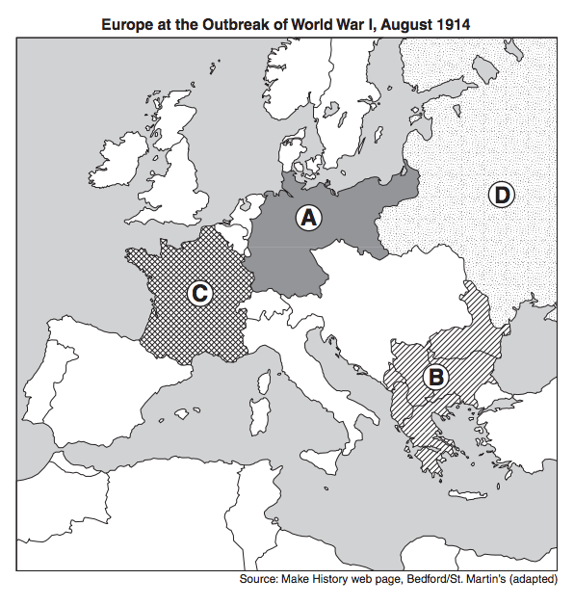

1. Which area of Europe was known as the “Powder Keg” of Europe prior to the outbreak of World War I?
   1. A (2) B (3) C (4) D
2. One similarity between the Sepoy Rebellion in India and the Boxer Rebellion in China is that both were
   1. religious reform movements
   2. reactions to the opium trade
   3. attempts to end foreign interference
   4. successful revolts against absolute monarchs
3. Between 1923 and 1938, which leader instituted a modernization program in Turkey?
   1. Shah Reza Pahlavi (3) Kemal Atatürk
   2. Jawaharlal Nehru (4) Ho Chi Minh
4. The rise of fascism in Germany between World War I and World War II is often associated with the
   1. promotion of ethnic diversity
   2. appeal of the doctrine of nonviolence
   3. establishment of a strong parliamentary system

(4) impact of the global economic depression

1. One way in which the conquest of Manchuria by the Japanese (1931) and the annexation of Czechoslovakia by Germany (1939) are similar is that these actions
   1. marked the end of the aggressive expansion of these nations
   2. demonstrated the weakness of the League of Nations
   3. reestablished the balance of power in the world

(4) led to the Long March

1. During World War II, the importance of the D-Day invasion of 1944 was that it
   1. forced Germany to fight on multiple fronts
   2. made Germany move their military to the Russian front

(3) ended the bombing of Germany

(4) demonstrated German military dominance

1. “The French Revolution is most important for having changed subjects to citizens.”

This statement emphasizes the shift from

* 1. religious traditions to secular values
  2. divine right rule to people’s participation in government
  3. rural lifestyles to urban lifestyles
  4. private property ownership to government ownership

1. Which geographic condition contributed to the defeat of Napoleon’s troops during the invasion of Russia?
   1. drought (3) severe flooding
   2. typhoons (4) harsh winter
2. One reason for the mass migration of many Irish to North America in the 19th century was
   1. a series of crop failures
   2. enforcement of a military draft
   3. civil war in Ireland
   4. an outbreak of malaria

*Base your answer to question 15 on the graphic organizer below and on your knowledge of social studies.*

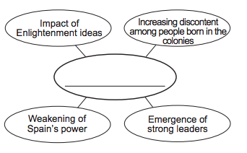

1. Which title best completes this graphic organizer?
   1. Reasons for Latin American Independence Movements
   2. Impact of the Scientific Revolution
   3. Causes of the Industrial Revolution
   4. Results of Nationalism in Europe
2. Which statement best reflects an effect of imperialism in Africa?
   1. Land was distributed equally between social classes.
   2. Territorial divisions were primarily established using tribal boundaries.
   3. Natural resources were exploited for the benefit of European powers.
   4. Timbuktu became the center of great learning.
3. Which event is considered the immediate cause of World War I?
   1. signing of the Treaty of Versailles
   2. invasion of Poland by Germany
   3. assassination of Archduke Francis Ferdinand
   4. use of unrestricted submarine warfare by Germany

*Base your answer to question 18 on the map below and on your knowledge of social studies.*

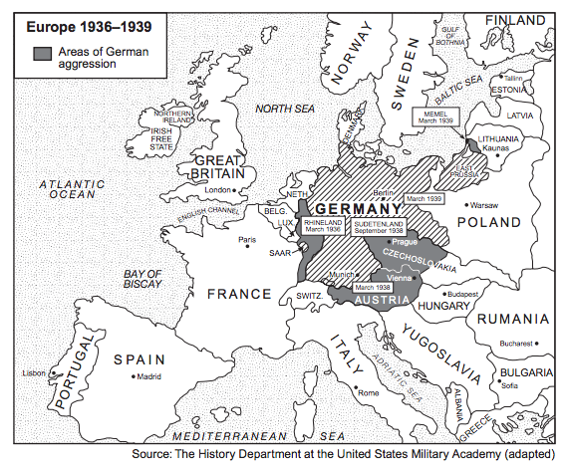

1. Based on the information provided by this map, how did adopting the policy of appeasement at the Munich Conference in September 1938 change Europe?
   1. The Rhineland was occupied by France.
   2. The Sudetenland was given to Germany.
   3. Germany transferred control of Memel to Lithuania.
   4. Austria became an independent state.
2. Which reform was included in Atatürk’s efforts to modernize Turkey?
   1. reintroducing strict Islamic law
   2. granting women the right to vote
   3. adopting Arabic script
   4. requiring men to wear a fez
3. Which political leader gained power as a result of the failing economy of the Weimar Republic?
   1. Adolf Hitler (3) Benito Mussolini
   2. Francisco Franco (4) Charles de Gaulle
4. What was a major effect of the Magna Carta and the English Bill of Rights on Great Britain?
   1. The power of the monarch was limited.
   2. Ireland revolted against the monarchy.
   3. Parliament was abolished.
   4. A renewed interest in Greek and Roman culture developed.
5. Which event is most closely associated with the French Revolution?
   1. Council of Trent
   2. Thirty Years’ War
   3. Reign of Terror
   4. Paris Peace Conference
6. A. Toussaint L’Ouverture declares Haiti independent.

B. Declaration of the Rights of Man and the Citizen is written in France.

C. The thirteen colonies gain independence from Great Britain.

D. Simón Bolívar frees Colombia from Spanish rule.

What is the correct chronological order for these events?

* 1. A → B → D → C (3) A → D → C → B
  2. C → B → A → D (4) D → C → B → A

1. • Irregular coastline

• Abundant mineral resources

• Large labor force

• Investment capital

Which country had these characteristics and used them to industrialize in the 1700s?

* 1. Germany (3) Great Britain
  2. Italy (4) Japan

1. Which statement represents a central idea of laissez-faire economics?
   1. Class struggles are based on inequities.
   2. Workers should form unions to better their conditions.
   3. Prices are best determined by supply and demand.
   4. The government should own all means of production.
2. A major goal of both the Sepoy Mutiny and the Boxer Rebellion was to
   1. remove foreign influences
   2. restore parliamentary government
   3. improve access to civil service examinations
   4. outlaw caste systems
3. In the late 19th and early 20th centuries, Japan rapidly industrialized. During which period did this change take place?
   1. Heian Court (3) Yuan dynasty
   2. Song dynasty (4) Meiji Restoration

*Base your answer to question 28 on the posters below and on your knowledge of social studies.*

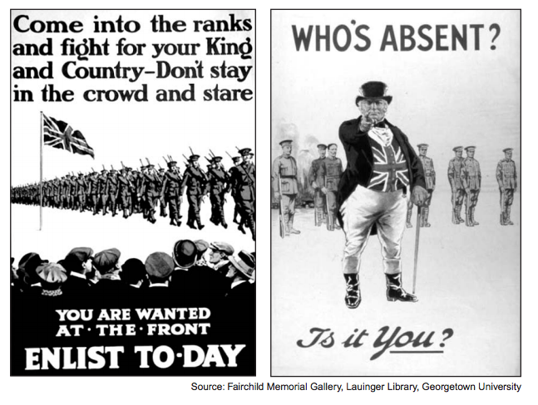

1. Which concept is represented in these World War I recruiting posters?
   1. justice (3) nationalism
   2. diversity (4) humanism

*Base your answer to question 29 on the excerpt below and on your knowledge of social studies.*

. . . No one in this country [Great Britain] who examines carefully the terms under which Hitler’s troops begin their march into Czecho-Slovakia to-day can feel other than unhappy. Certainly the Czechs will hardly appreciate Mr. Chamberlain’s phrase that it is “peace with honour.”. . .

* + - “Return from Munich,” Guardian, October 1, 1938

1. The author of this excerpt is reacting to Prime Minister Chamberlain’s policy of
   1. self-determination (3) containment
   2. ethnic segregation (4) appeasement
2. Which action is associated with Joseph Stalin?
   1. expanding privatization
   2. establishing five-year plans
   3. encouraging glasnost
   4. promoting détente
3. Oliver Cromwell led the Puritan Revolution in England in response to the
   1. passage of the Bill of Rights
   2. autocratic rule of the king
   3. implementation of mercantilism
   4. defeat of the Spanish Armada

*Base your answer to question 32 on the illustration below and on your knowledge of social studies*

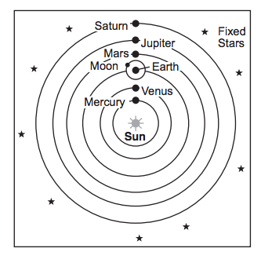

1. Which individual supported the theory represented in this illustration?
   1. Socrates (3) Dante
   2. Ptolemy (4) Galileo
2. Which issue was a cause of the French Revolution?
   1. ineffective rule of Napoleon Bonaparte
   2. nationalization of the Church
   3. outrage over the use of the guillotine by the Committee of Public Safety

(4) demand of the Third Estate for more political power

1. A major reason the Industrial Revolution developed in Great Britain in the 1700s was because of Great Britain’s
   1. geographic features
   2. immigration policies
   3. use of collectivization
   4. access to imported oil
2. • Toussaint L’Ouverture

• Bernardo O’Higgins

• José de San Martín

These individuals had their greatest impact on the

* 1. unification of Italy
  2. independence movements in Latin America
  3. Zionist movement
  4. Catholic Counter Reformation

1. What is a major belief associated with Marxism?
   1. The proletariat would rise up and overthrow the bourgeoisie.
   2. Religion should be more important than political forces.
   3. Private ownership of property should be expanded.

(4) Peasants would gain control of overseas markets.

1. The Berlin Conference in 1884 was significant because it
   1. promoted Belgium as a world power
   2. established rules for the European division of Africa
   3. called for a war against England
   4. ensured ethnic harmony in the Middle East
2. Japan began an aggressive policy of imperialism in the late 19th and early 20th centuries because Japan
   1. needed raw materials for its factories
   2. hoped to spread Shinto
   3. sought Western technology
   4. wanted revenge for the Opium Wars
3. The immediate cause of World War I was the
   1. assassination of Archduke Ferdinand
   2. Japanese alliance with Germany
   3. treaty agreement at Versailles
   4. German invasion of Poland
4. The Bolshevik Revolution of 1917 in Russia was caused in part by
   1. a forced famine in Ukraine
   2. the failure of Czar Nicholas II to come to Serbia’s aid
   3. a shortage of military supplies and food during World War I
   4. the establishment of Lenin’s New Economic Policy (NEP)
5. One way in which Kemal Atatürk of Turkey and Shah Reza Pahlavi of Iran are similar is that both leaders
   1. implemented programs to modernize their nations
   2. supported increased rights for ethnic minorities
   3. adopted policies of nonalignment
   4. established theocracies based on Islam

*Base your answer to question 42 on the passage below and on your knowledge of social studies.*

...The German people were never more pitiable than when they stood by and watched this thing done. For the raiders who were let loose on the streets and given a day to sate [indulge] the lowest instincts of cruelty and revenge were indeed an enemy army. No foreign invader could have done more harm. This is Germany in the hour of her greatest defeat, the best overcome by the worst. While many protested at the outrages, and millions must have been sickened and shamed by the crimes committed in their name, many others looked on stolidly or approvingly while the hunters hunted and the wreckers worked. There are stories of mothers who took their children to see the fun....

* + - New York Times, November 12, 1938

1. This 1938 passage criticizes those German people who did not
   1. participate in these demonstrations
   2. condemn the violent acts of Kristallnacht
   3. support the government’s policy in Austria
   4. resist the war effort
2. What was one geographic characteristic of Germany that influenced the outcomes of both World War I and World War II?
   1. Mountainous topography protected Germany from the opposing side.
   2. A lack of navigable rivers in Germany slowed transportation.
   3. Excellent harbors allowed Germany to defeat Great Britain’s naval forces.
   4. Its central location in Europe resulted in Germany having to fight on two fronts.
3. What was one effect of the Latin American revolutions of the 19th century?
   1. Democracy became the dominant political system in Latin America.
   2. European colonialism replaced the independent governments of Latin America.
   3. Many Latin American countries achieved independence.
   4. Countries in Latin America deported most people with European ancestry.
4. Galileo Galilei and Sir Issac Newton are most closely associated with
   1. initiating religious reforms
   2. leading political revolutions
   3. conducting investigative experiments
   4. engaging in foreign conquests
5. Maximilien Robespierre and the Jacobins are best known for
   1. instituting the Reign of Terror
   2. protecting freedom of religion
   3. supporting the reign of King Louis XVI
   4. sending French troops to fight in the American Revolution
6. The unification of Italy and the unification of Germany show that
   1. socialism was an effective way of organizingthe economy
   2. nationalism could be used to consolidate political interests
   3. colonialism could be used to spread European civilization
   4. interdependence was a significant obstacle to waging war
7. During the Industrial Revolution, which development resulted from the other three?
   1. Factory conditions affected people’s health.
   2. Labor unions were formed.
   3. Unskilled laborers received low wages.
   4. Machinery replaced workers.
8. Which phrase best illustrates the theory of laissez-faire capitalism?
   1. businesses operating with little government regulation
   2. the state establishing production quotas
   3. central planning committees setting prices on goods
   4. decisions related to distribution being based on community traditions
9. According to Thomas Malthus, the rate of increase for human populations in relation to the rate of increase for food production was a problem. Malthus believed that
   1. industrial development would severely limit population growth

(2) famine and war were natural checks on population growth

(3) countries with larger populations would conquer countries with smaller populations

(4) food production would increase at a faster rate than populations would

1. An incompetent government, massacres on Bloody Sunday, and the high costs of World War I were causes of the
   1. Mexican Revolution
   2. Boxer Rebellion
   3. Sepoy Mutiny
   4. Russian Revolution
2. Which sequence of events is in the correct chronological order?
   1. rise of Nazism → Treaty of Versailles → German invasion of the Soviet Union
   2. Treaty of Versailles → rise of Nazism → German invasion of the Soviet Union
   3. German invasion of the Soviet Union → rise of Nazism → Treaty of Versailles
   4. Treaty of Versailles →German invasion of the Soviet Union → rise of Nazism
3. One similarity between the Magna Carta and the English Bill of Rights is that both documents
   1. set up a two-party political system
   2. placed limits on the power of the monarch
   3. established the right to inherit the throne
   4. guaranteed equal rights for all citizens
4. Which statement represents a key idea directly associated with John Locke’s Two Treatises of Government?
   1. Freedom of speech should be denied.
   2. The king’s power on Earth comes from God.
   3. All people are born with the right to life, liberty, and property.
   4. Individuals acting in their own self-interest will achieve economic success.

*Base your answer to question 55 on the partial outline below and on your knowledge of social studies.*

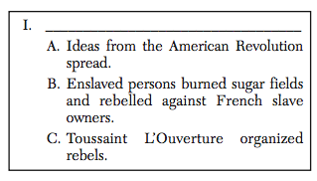

1. Which title best completes this partial outline?
   1. Causes for Bismarck’s Rise to Power
   2. Factors of the Haitian Revolution
   3. Results of the Munich Pact
   4. Situations Contributing to the Zionist Movement
2. Belief in the ideas of the Enlightenment and discontent within the Third Estate were causes of the
   1. French Revolution
   2. Counter Reformation
   3. Industrial Revolution
   4. Spanish Reconquista
3. In the early 18th century, the Agricultural Revolution in Great Britain resulted in urbanization because
   1. enslaved persons replaced free laborers on farms
   2. factory work strengthened extended families
   3. displaced rural workers migrated to find jobs
   4. the middle class decreased in size

*Base your answer to question 58 on the passage below and on your knowledge of social studies.*

… Since the beginning of China as a nation, we Chinese have governed our own country despite occasional interruptions. When China was occasionally occupied by a foreign race, our ancestors could always in the end drive these foreigners out, restore the fatherland, and preserve China for future generations of Chinese. Today when we raise the righteous standard of revolt in order to expel an alien race [the Manchus] that has been occupying China, we are doing no more than our ancestors have done or expected us to do. Justice is so much on our side that all Chinese, once familiarizing themselves with our stand, will have no doubt about the righteousness of our cause.…“A Public Declaration,” 1906

1. Which conclusion can be drawn from this passage?
   1. China can no longer remain isolated from its neighbors.
   2. The Chinese people are happy with the rule of the Manchu.
   3. The Chinese people wanted to end foreign occupation.
   4. China has prospered under the rule of foreign powers.

*Base your answer to question 59 on the cartoon below and on your knowledge of social studies.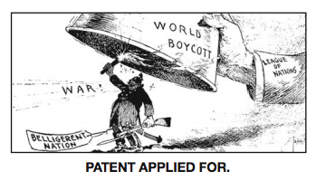*

1. Which statement best reflects the main idea of this cartoon?
   1. The League of Nations is stopping world boycotts.
   2. The League of Nations hopes to use boycotts to end war.
   3. Belligerent nations wish to be included in the League of Nations.
   4. War is likely if the League of Nations acts.
2. A key idea in the Communist Manifesto by Karl Marx and Friedrich Engels is that workers should support the
   1. overthrow of the capitalist system
   2. establishment of labor unions
   3. legislative regulation of wages and working conditions

(4) technological changes in production methods

1. Which change is associated with Meiji Japan?
   1. expansion of feudal political and social values
   2. modernization of the economy and government
   3. adoption of isolationist policies
   4. abandoning plans for an overseas empire
2. Which action contributed to the success of Lenin’s communist revolution in Russia?
   1. Peasants were promised land reform
   2. Businessmen were encouraged to form monopolies.
   3. Landowners were offered tax relief.
   4. Factory workers were required to start small businesses.
3. • Treaty of Nanjing gives control of Hong Kong to Great Britain.

• French government sets up a protectorate in Cambodia.

• Italian forces occupy Ethiopia.

Which policy is most closely associated with theses tatements?

* 1. Détente (3) nonalignment
  2. Appeasement (4) imperialism

1. What was a major cause of the famines in Ukraine between 1929 and 1935?
   1. war with Chechnya and Armenia
   2. forced collectivization by the government
   3. lack of arable land in the region
   4. movement of workers to Siberia
2. The British reliance on India as a market for its manufactured goods caused Mohandas Gandhi to
   1. run for a seat in the British Parliament
   2. lead the Sepoy Rebellion
   3. support traditional caste divisions
   4. refuse to buy British textiles
3. Which headline is most closely associated with the cities of Hiroshima and Nagasaki?
   1. “Japan Signs Treaty of Kanagawa”
   2. “Nuclear Bombs Dropped on Japan”
   3. “Japan Invades Korea”
   4. “Japan Hosts Discussion on Greenhouse Gases”

*Base your answer to question 67 on the cartoon below and on your knowledge of social studies.*

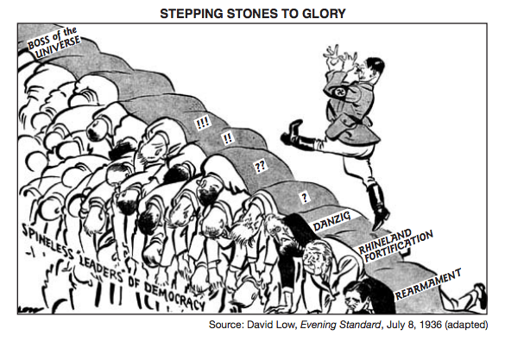

1. The leaders in this 1936 cartoon are depicted as “spineless” because they
   1. signed the Treaty of Versailles
   2. wanted to avoid global conflict at any cost
   3. depended on economic measures to stop aggression
   4. recognized the communist government in the Soviet Union
2. One way in which the reigns of Peter the Great and Catherine the Great are similar is that both leaders
   1. promoted the emancipation of serfs
   2. strengthened the role of the Duma and centralized royal power
   3. shared their power with the Russian Orthodox Church
   4. pursued a policy of westernization and expansion
3. Which institution became stronger and limited the monarchy in order to end absolutism in England?
   1. Banks (3) universities
   2. Parliament (4) Anglican Church
4. Which idea is central to John Locke’s Two Treatises of Government?
   1. A government’s power comes from the consent of the people.
   2. Predestination will determine who will go to heaven.
   3. Famine, disease, and conflict are natural checks on population growth.
   4. The have-nots will rise up and overthrow the government of the haves.
5. The Andes Mountains and the Amazon River basin affected Simón Bolívar’s efforts to bring about
   1. economic imperialism
   2. political unification
   3. religious solidarity
   4. technological improvements
6. • Appointment of Otto von Bismarck as Chancellor

• Austro-Prussian War, 1866

• Franco-Prussian War, 1870–1871

These events led directly to

* 1. the unification of Germany
  2. foreign rule in Italy
  3. the rebellion of the Sepoys
  4. an alliance between Serbs and Russians

1. The mass emigration of the Irish in the mid-19th century was primarily a result of
   1. mandatory military service
   2. famine
   3. civil war
   4. farm mechanization
2. The 19th-century ideas of Social Darwinism and the “White Man’s Burden” were often used to justify
   1. isolationism (3) imperialism
   2. appeasement (4) disarmament
3. Before 1914, nationalism in the Balkan Peninsula contributed to
   1. resistance by ethnic groups to Austrian rule
   2. campaigns by foreign diplomats against the use of trench warfare
   3. the inability of countries to make reparation payments
   4. the rejection of the Versailles Treaty by combatants

*Base your answer to question 76 on the cartoon below and on your knowledge of social studies.*

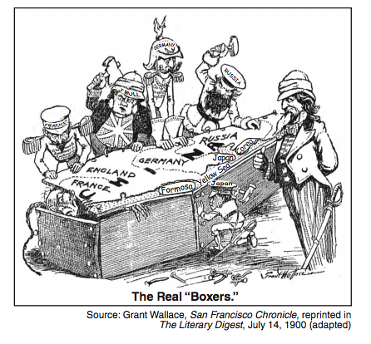

1. The idea expressed in this cartoon is most closely associated with the
   1. alliances formed in Europe
   2. division of Africa discussed at the Berlin Conference
   3. spheres of influence established in China by foreigners
   4. border changes made at the Congress of Vienna
2. Which statement regarding World War I is an opinion rather than a fact?
   1. European countries increased the production of weapons during the war.
   2. The governments of most countries stated that the period of conflict would be short.
   3. Propaganda posters were used to gain support for the war.
   4. Citizens of the Allied nations showed more patriotism than those of the Central Powers.
3. Which action was taken by the Bolsheviks under the leadership of Vladimir Lenin?
   1. supporting a traditional economy
   2. eliminating political opposition
   3. surrendering to the Provisional Government
   4. extending the war against Austria-Hungary
4. An economic change introduced in the Soviet Union under Joseph Stalin would include
   1. establishing free-market reforms
   2. boycotting Baltic Sea trade routes
   3. focusing on the production of consumer goods
   4. collectivizing agriculture
5. Which of these World War II events happened first?
   1. Battle of Britain
   2. D-Day invasion
   3. invasion of Poland
   4. dropping of an atomic bomb on Hiroshima
6. Disintegration of the Austro-Hungarian Empire, creation of new nation-states in central Europe, and Germany’s loss of colonies were all consequences of
   1. the Napoleonic Wars
   2. the Franco-Prussian War
   3. World War I
   4. World War II
7. Which situation was a result of the 1884 Berlin Conference?
   1. Africa was divided without regard to ethnic groups.
   2. Monarchies were restored throughout Europe.
   3. The slave trade with South America was eliminated.
   4. The League of Nations was formed.

*Base your answer to question 83 on the time line below and on your knowledge of social studies.*

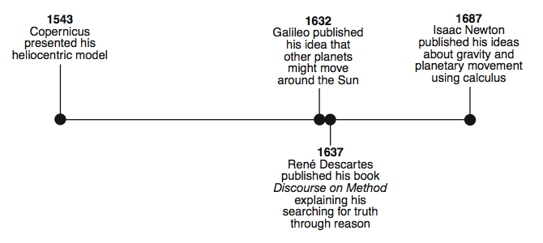

1. Which historical period is most closely associated with these achievements?
   1. Pax Romana (3) European Middle Ages
   2. Age of Alexander the Great (4) Scientific Revolution
2. The workers in industrial countries must create a revolution, overthrow the existing governments using force if necessary, and then create a new classless society.

This statement expresses the views of

1. Mikhail Gorbachev (3) Karl Marx
2. Jomo Kenyatta (4) Kemal Atatürk
3. The Nuremberg laws are best described as efforts of the
   1. Roman Catholic Church to punish heresy
   2. major articles in the Declaration of the Rights of Man
   3. specific laws contained in Justinian’s Code
   4. anti-Semitic laws of 20th-century Germany