Energy Review

**What is ENERGY**? *The ability to do work or cause change*

**The LAW OF CONSERVATION OF ENERGY states:** ______________________________________________________________________________________________________________________________________________

**2 types of Energy**

[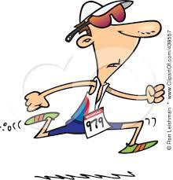](http://www.google.com/imgres?imgurl=http://www.xfactorfitnesssolutions.com/blog/wp-content/uploads/2011/08/438557-Royalty-Free-RF-Clip-Art-Illustration-Of-A-Cartoon-Man-Running-In-A-Triathlon.jpg&imgrefurl=http://lol-rofl.com/cartoon-people-running/&h=450&w=433&tbnid=Qu9m8nBb5Z2w2M:&zoom=1&q=cartoon%20running&docid=4BKAzIUCE-73MM&ei=xK-IVJzgLfjGsQTW8IKgBw&tbm=isch&ved=0CD4QMygVMBU&iact=rc&uact=3&dur=1101&page=1&start=0&ndsp=26)[](http://www.google.com/imgres?imgurl=http://toonclips.com/600/10641.jpg&imgrefurl=http://toonclips.com/design/10641&h=620&w=600&tbnid=H9Uq-cww8wYLGM:&zoom=1&q=cartoon%20with%20slingshot&docid=j9aAjdqLXJGIQM&ei=crCIVNyyO8HPsQSm24HYAw&tbm=isch&ved=0CB8QMygDMAM&iact=rc&uact=3&dur=669&page=1&start=0&ndsp=28)

**Potential Energy**

***________________________________________________***

**Kinetic Energy**

**________________________________________________________________**

**Types of Kinetic Energy**

* M___________________
* S___________________
* T___________________
* Electromagnetic Energy
* Nuclear Energy
* Electrical Energy

**Types of Potential Energy**

* (GPE)____________________________________
* (CPE)____________________________________
* (EPE)_____________________________________

**Types of Potential Energy**

|  |  |  |
| --- | --- | --- |
| **Type of Potential Energy** | **Definition** | **Example** |
| **Gravitational Potential Energy** | ***Energy due to an objects position _______________***  ***______________________ GPE increases as the distance from Earth’s surface _________________***  **GPE =** MASS **x**  HEIGHT | * **An apple falling from a tree** * **________________ ___**   **______________________**   * **___________________**   **______________________** |
| **Chemical Potential Energy** | ***Energy stored in* _________**  **_______________________.** | * **Potential energy found in an apple** * **___________________**   **_____________________**   * **__________________**   **_____________________** |
| **Elastic Potential Energy** | ***Energy stored when an object is* ________________ *or* _____________________** | * **Potential energy in a sling shot.** * **___________________**   **______________________**   * **___________________**   **______________________** |

**Types of Kinetic Energy**

|  |  |  |
| --- | --- | --- |
| **Type of Kinetic Energy** | **Definition** | **Example** |
| **Mechanical Energy** | Energy that _________________ | * _______________ * _______________ * _______________ |
| **Sound Energy** | Energy that results from ________________in _________________ |  |
| **Thermal Energy** | A measure of the total amount of _________________ energy in an object |  |
|  |  |  |
|  |  |  |
|  |  |  |

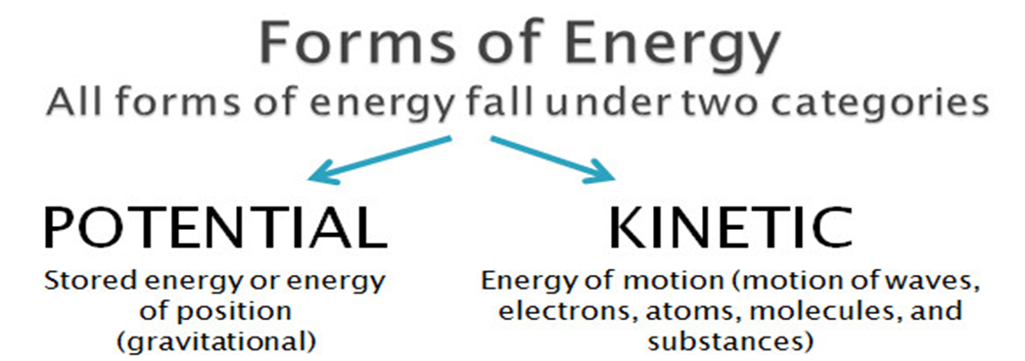

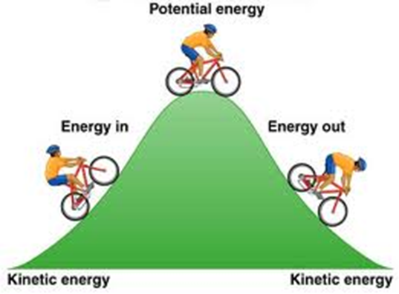

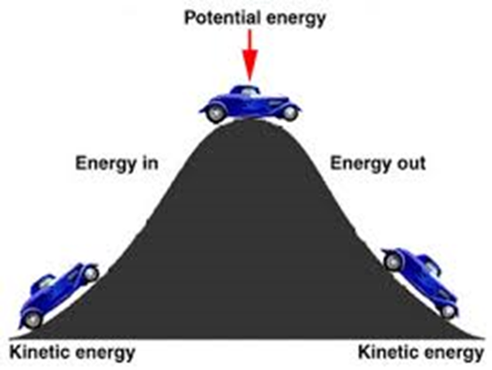

Describe the transfer of energy. As Kinetic energy increases, what happens to potential energy? AND as potential energy increases, what happens to kinetic energy? _____________________________________________________________________________________________________________________________________________________________________________________________________________________

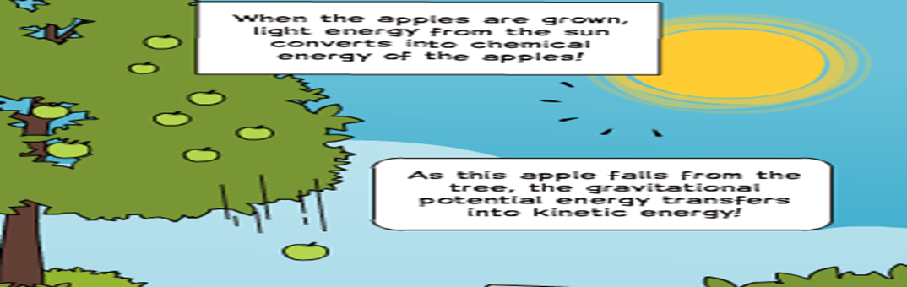***Gravitational Potential Energy***

***Elastic Potential Energy***

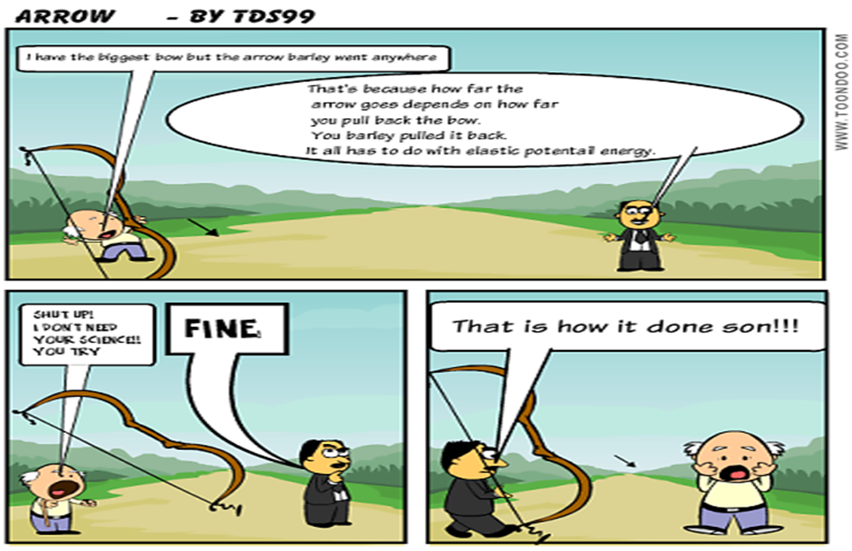

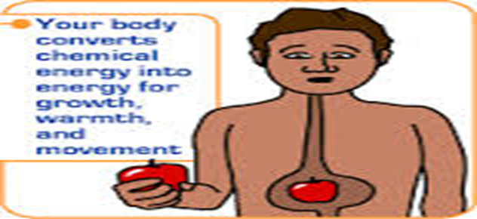

***Chemical Potential Energy***