United States History and Government (11R)
Mr. Greeney
Email: rgreeney@csh.k12.ny.us

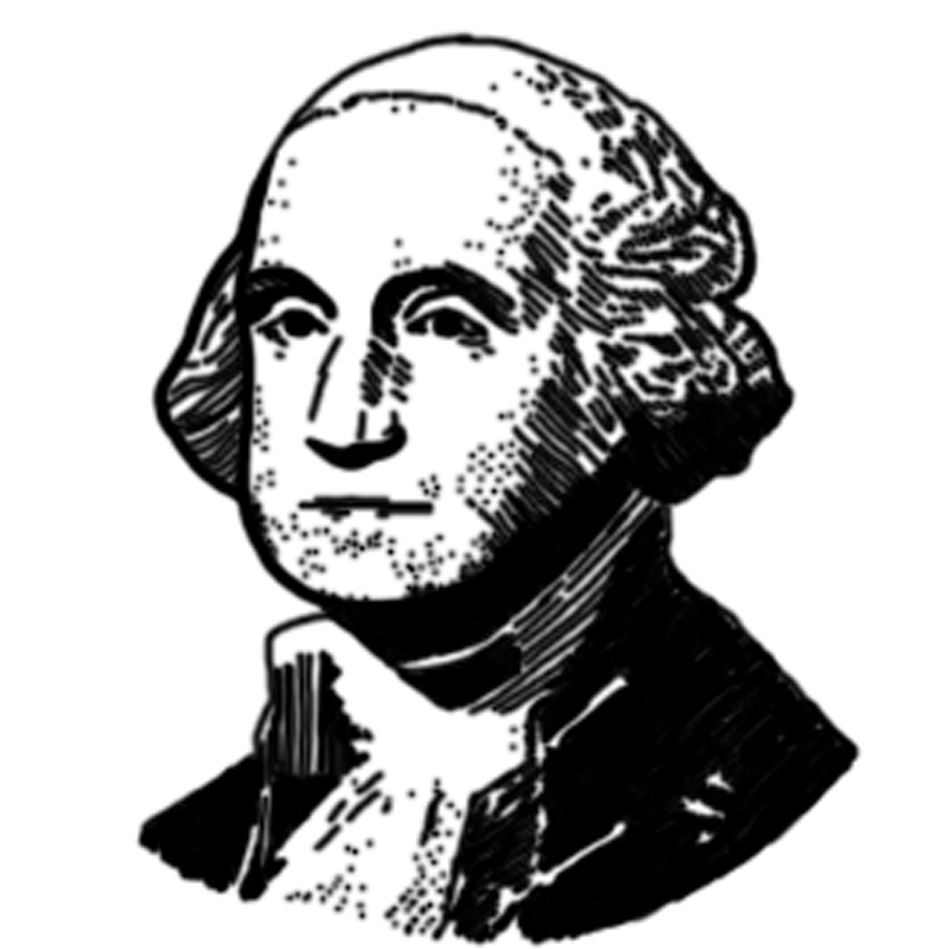
Welcome to United States History and Government! This course is intense and will cover the history of the United States from its origin until the present day era. We will be studying different events that have influenced the development of America. This class ultimately concludes with a regents exam in June

. 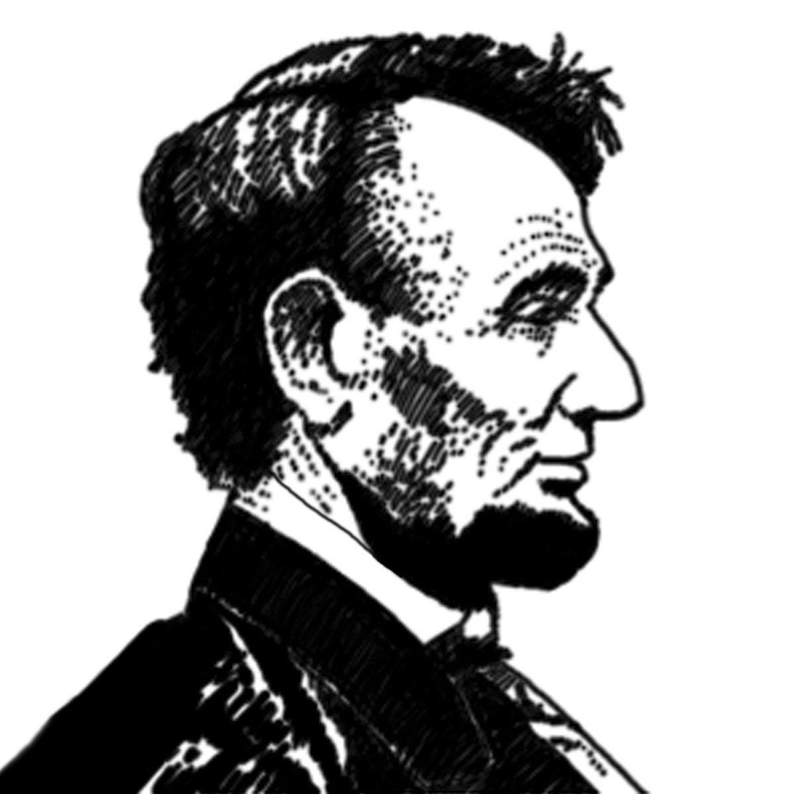

Behavior:
Students are expected to follow the classroom rules and behave in a mature manner at all times. All students that violate the rules will be subject to the appropriate listed disciplinary actions.

Materials:
In order to have a successful year the following materials are needed:
- 1 inch binder
- Loose-leaf paper
- Dividers
- Pens/pencils
- 2 folders (one will be left in class)

You are responsible for keeping all handouts in your folder. We will have notebook/folder quizzes. You are expected to bring these materials to class everyday.

Attendance:
All students must be on time and attend class regularly. The classroom door will be closed at the beginning of the period. You should sit in your seat and begin setting up your notebook for the day. You are responsible for all missed work and notes. Please come to see me when you are absent from class.

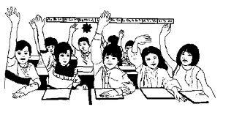

Assessment:
Each student will be evaluated on the following items:
- Tests/quizzes
    - Tests (100 points each)
    - Quizzes (vary between 10 and 50 points)
- Homework/classwork/journals (5 points)
- Projects/presentations/ group work (approximately 50 points)
- DBQ/Thematic Essays (points will vary)
- Midterm/ Regents Exam (midterm counts twice)
- Preparation/participation (approximately 20 points)

Grade is calculated by totaling all points earned and dividing by the total points offered for the marking period.

A pop quiz on the assigned readings may be given to ensure the work is being completed. Homework assignments will be collected at random.

