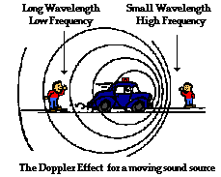
TOPIC 3 REVIEW SHEET

Origin of Universe:
Began with the BIG BANG – all matter condensed
into a single point, & exploded outward in all directions
How do we know?
- Background radiation
- DOPPLER EFFECT
- objects moving away have a RED SHIFT, towards have a BLUE SHIFT
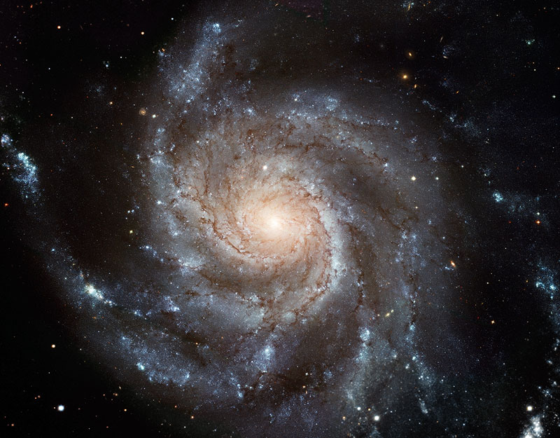

*Look at your ESRT regarding color and wavelength.

How do we know the Universe is moving away or expanding?
Answer: Redshift. The wavelengths are longer.

Parts of Universe:
- Galaxies (ours: Milky Way, a spiral galaxy)
- Stars (ours: Main-Sequence, SOL)
  - Produce energy via nuclear fusion – combining atoms
  - Luminosity – how bright a star would be if it were as close to us as our sun is
  - Born as condensing & heating clouds of dust & gas, die based on their mass (small stars: red giant->white dwarf-> black dwarf, large stars: supernova -> black hole)

Parts of Solar System:
1.) Planets – TERRESTRIAL (small, inner, rocky, dense) vs.
JOVIAN (large, outer, gaseous, light)
2.) Moons, comets, asteroids, meteorites

Planetary Motions:
- ROTATION: spin on axis, controls length of DAY
- REVOLUTION: orbit around sun, controls length of YEAR
- orbits’ shape is an ellipse – (oval) the more of an ECCENTRICITY an orbit has, the more oval-like the orbit is.
ECCENTRICITY =

Distance between foci

Length of major axis

MAXIMUM ECCENTRICITY = 1.0 (looks like a straight line)
MINIMUM ECCENTRICITY = 0.0 (looks like a perfect circle)

Earth is closest to the sun during WINTER!

*Please remember, One of the Foci is the Sun.

Orbital force:
DYNAMIC EQUILIBRIUM between Gravity and Inertia

Gravity: controlled by MASS and DISTANCE
Inertia: objects at rest tend to stay at rest, objects in motion tend to stay in
Motion

Aphelion and Perihelion
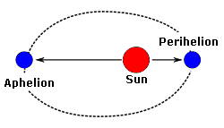
Aphelion= “A” Away. This is when Earth is furthest away from the sun. (However, this happens during our summer because of Earth’s Tilt).

Perihelion= This is when Earth is closest to the sun. This is the point with the fastest Kinetic Energy, or movement. This also is where the force of Gravity is the greatest.

