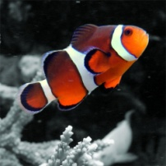
Marine Biology
Miss Oshan

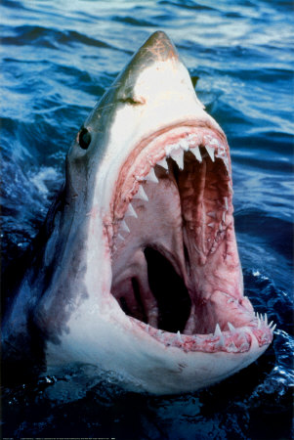
Welcome back and welcome to Marine Biology. This is a half year course designed to introduce and excite students about the branch of biology that deals with water environments. Students will be conducting laboratory exercises and engaging in student-centered learning experiences to develop a broad, general understanding of life forms found in salt-water environments. A substantial portion of the course will focus on the variation and diversity of animals and plants found in the oceans. Also, included will be an overview of environmental problems that exist in the ocean environment and an examination of the causes of those issues.

Students/Class Expectations

- Respect! Respect! Respect!
- Be present and be on time.
- Come prepared
- No cell phones – off and out of sight
- Keep an open mind.

Teacher Expectations

- I will be fair and grade all assignments in a timely manner.
- I will do my best to convey the scientific concepts in a way which is understandable, exciting and relevant to your lives.
- I will contact parents when necessary and work with them to determine the best way to obtain the desired educational goals for their child.

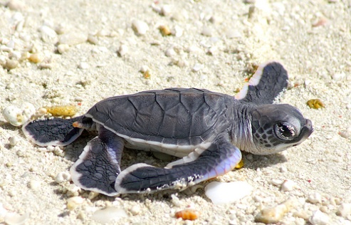
Materials

- A binder or folder to keep handouts and notes in.
- Pens/pencils – colored pencils for drawings
- Place to take notes – either in the binder or
in a separate single subject notebook devoted only to Marine.

Grades

Your quarterly grades will be determined by your performance on homework assignments, lab reports, projects, papers, quizzes,tests and ATTENDANCE. Each one of the above mentioned assessments will be given a point value and at the end of the quarter your grade will be determined by dividing the amount of points you earned by the amount of you could have attained. For example, if you earn 300 points out of a possible 400 your average would be 300/400 or 75%. This 75% would then be converted into a letter grade of a C. Points will assigned accordingly, for example a homework may be worth 5 points where a quiz would be worth 20 points and test worth 60 points. There will be a daily point value assigned to attendance resulting in an attendance grade at the end of the quarter.

Topics of Study

  - Introduction to Marine Science
  - Marine Environments
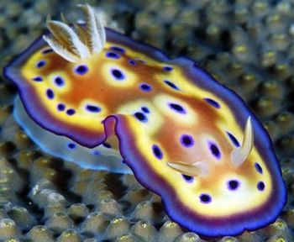
  - Properties of water – light, sound, pressure, salinity
  - Unicellular & Simple Marine Organisms
  - Marine Invertebrates
  - Marine Vertebrates
  - Tides, Waves and Currents

Optional Topics
  - Hydrothermal Vents
  - Deep Ocean Environment
  - Coral Reef Systems
Sea Slug

Teacher will cover topics I – VII and one optional topic in this half-year course. Due to the abbreviated nature of this course, it is not expected that all in the information in topics III-VI be covered in depth. It is essential to introduce and provide basic information about the organisms found in the oceans, but details may be omitted due to time constraints. The goals of this course is to provide a basic understanding of the biology of the ocean.

The first part of the course will involve the Marine Environment. The second half of the course will involve the living organisms that inhabit our marine environments. Student will be involved in a number of different projects that involve content, technology and public speaking skills.
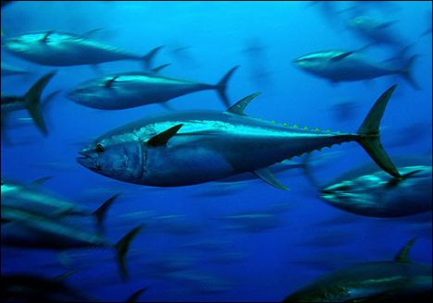
Bluefin Tuna
Teacher email: eoshan@csh.k12.ny.us

I have read and understand the policies of this class.

Student ________________________________________________

Parent/Guardian ______________________________________________

